ENDEPENDENCE CENTER NEWSLETTER AUGUST 2023

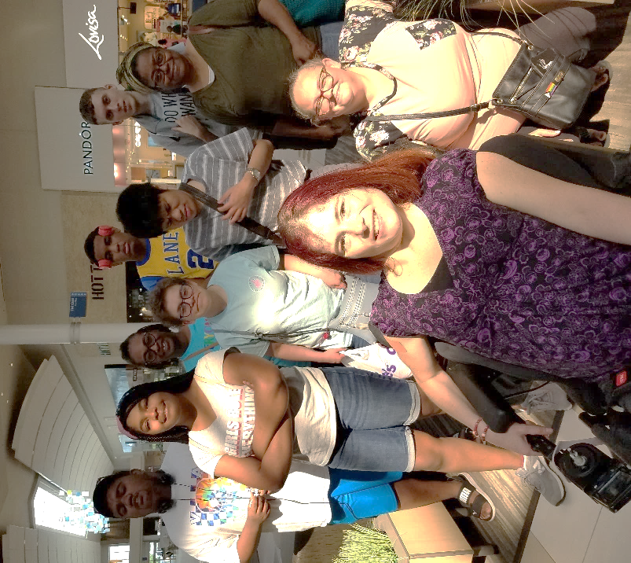
YEA! In Full Swing
The ECI Summer Youth Program, Youth Endependent Advocates (YEA!) kicked off on July 10. YEA is halfway through an exciting time learning independent living skills, goal planning, work readiness, and more.
Pictured right: A black and white picture of a female ECI staff member using a wheelchair. Behind her stands a group of teens of all ages with other ECI staff, taken at a community outing.
Note: the monthly Saturday Youth Group will not meet in August.

Highlights from Recent Events:

Sentara Gun Violence Prevention Event
On June 30, ECI staff attended the Annual Gun Violence Prevention event at Sentara Norfolk General to discuss ECI services and meet with doctors, nurses, and hospital staff.
Employment Fair
On July 13, ECI participants attended an Employment Fair at the Hampton Roads Workforce Council. Over 60 job seekers attended.
Portsmouth Department of Social Services
On July 15, ECI staff had the opportunity to share more about ECI services and the Virginia Department for the Deaf and Hard of Hearing Technology Assistance Program at a Portsmouth Department of Social Services event.
Current participants should be on the lookout for the annual ECI Participant Satisfaction Survey to arrive in their mailboxes in the coming weeks. Your opinion about how ECI works with you on your goals is important. We want to know about your experiences at ECI. Your feedback will help ECI to provide needed services.
AUGUST 2023

Endependence Center, Inc. Events
Held at ECI, 6300 E. Virginia Beach Blvd, Norfolk

9th CAC Consumer Advisory Committee 2:00pm – 3:30pm
WED The agenda for this meeting is to discuss CAC surveys and results.

16th Independent Living Skills Training: What Are Your Goals?
WED 2:00pm – 3:30pm
Goal setting refers to the process of setting specific, attainable targets. Learn why goal setting is so important in life and how to do it.

23rd Advocacy Group: ADA, Local Government 2:00pm – 3:30pm
WED Earlier this summer the ECI Advocacy Group established a process to review information from local governments about the Americans with Disabilities Act. This August meeting will discuss areas of local government that the Group will focus on. If you have had difficulty accessing a local government program or needed a program modification that was not provided, please join the Group on August 23 to discuss what we might do together to resolve the problem.

30th VBthrive Presentation: Coaching & Support 2:00pm – 3:30pm
WED If you are a Virginia Beach resident and want to expand your ability to be self-sufficient, this training is for you. VBthrive is a program ECI is partnering with to provide coaching and support to help you reach your goals.

Community & Participant-Led Events
Transportation tickets are NOT provided to attend community events.

4th Silent Dinner 5:00pm – 8:00pm
FRI Lynnhaven Mall (701 Lynnhaven Parkway, Virginia Beach)
Southside Silent Dinner is a silent, social, family-friendly event for the deaf community, CODA (Child of Deaf Adult), ASL beginners and students, and others interested in ASL.

15th Crazy Buffet & Grill 12 noon – 2:30pm
TUE This month's participant-led activity will be held at Crazy Buffet and Grill, located at 1745 Parkview Drive, Chesapeake.

20th TOUCH Group: Cookout 11:00am - 3:30pm
SUN Portsmouth City Park (140 City Park Avenue, Portsmouth)
We encourage everyone to come out for our first cookout. Join us for food, games, prizes and conversation. Bring your family and friends! For more information, contact Montrell Rodgers at (757) 238-1293 or vatouch.22@gmail.com.
SUNDAY | MONDAY | TUESDAY | WEDNESDAY | THURSDAY | FRIDAY
*These events are not organized by ECI. Bus and paratransit tickets will not be provided by ECI. |  | 1 | 2 | 3 | 4
Silent Dinner*

@ Lynnhaven Mall
5:00pm – 8:00pm
6 | 7 | 8 | 9 | 10 | 11
 |  |  | Consumer Advisory Committee  @ ECI  2:00pm – 3:30pm | ECI CLOSED FOR STAFF EVENT
13 | 14 | 15 | 16 | 17 | 18
 |  | Participant Led Event*  @ Crazy Buffet & Grill  Chesapeake  12noon – 2:30pm | ILS Training:  Goal Setting  @ ECI  2:00pm – 3:30pm
20 | 21 | 22 | 23 | 24 | 25
TOUCH Group Picnic*  @ Portsmouth City Park  11:00am – 3:30pm |  |  | Advocacy Group  ADA & Local Government  @ ECI  2:00pm – 3:30pm
27 | 28 | 29 | 30 | 31
VBthrive Presentation

@ ECI
2:00pm – 3:30pm

August 2023

Disability Advocacy & Services

Endependence Center, Inc.
6300 East Virginia Beach Blvd
Norfolk, VA 23502

Phone:
(757) 461-8007 Voice
(757) 461-7527 TDD

E-Mail:

ecinorf@endependence.org

Website:

www.endependence.org

Newsletter alternate format:
contact (757) 351-1598 or ehoapili@endependence.org

Schedule Changes
Check the ECI website: www.endependence.org
or call
(757) 461-8007, option 4

ELECTRONIC SERVICE REQUESTED

Accommodations
To request accommodations
for ECI activities:
(757) 351-1586 voice
(757) 461-7527 TDD
tmanno@endependence.org

Non-Profit Org.
U.S. Postage
PAID
Norfolk, VA
Permit No. 102

Place label here

Social Media
Facebook: Endependence Center, Inc.-Norfolk, Virginia

