ENDEPENDENCE CENTER NEWSLETTER SEPTEMBER 2023

ECI to Host Event with REV UP Virginia for Disability Voting Rights Week.
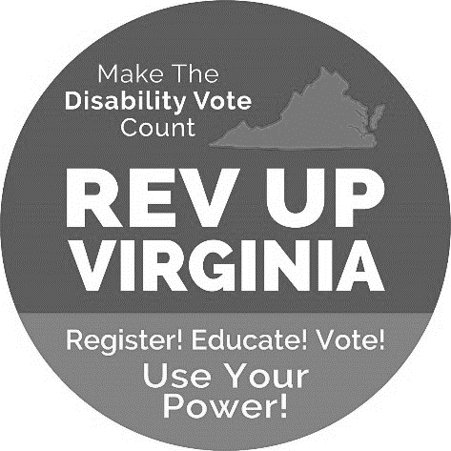
This November, all 40 seats of the Virginia Senate and all 100 seats of the Virginia House of Delegates will be on the ballot, as well as many local offices. Due to redistricting, new districts have been drawn, and some voting locations changed. ECI is working with REV UP Virginia (Register, Educate, Vote, Use your Power) and local organizations to celebrate Disability Voting Rights Week.
On Saturday, September 9th, from 11:00am – 3:00pm, ECI will host an event with REV UP Virginia, where Virginians with disabilities can register to vote, confirm their new district, learn about accessible voting and mail-in ballots, and even see an accessible voting machine! There will also be an open forum to discuss why our vote matters. ASL Interpreters will be available. For other accommodation needs, e-mail ehoapili@endependence.org.
Let’s SHOW THE POWER OF THE DISABILITY VOTE and make sure WE’RE HEARD in EVERY election. YOU have the POWER to MAKE A DIFFERENCE!
The national REV UP campaign is a program of the American Association of People with Disabilities. Visit www.aapd.com/revup for more information.

Prepare for Hurricane Season
Hurricane season began June 1 and goes through November 30. Being ready for a hurricane or other disaster is a part of maintaining your independence. Each person with a disability should develop a Personalized Emergency Plan that can be implemented during a disaster. For more information, visit www.ready.gov. We have also posted links and checklists to our website.

Housing Wait List Opening at Kindred
For a limited time, Norfolk Redevelopment and Housing Authority (NRHA) will open its Project Based Voucher/Low-Income Housing Tax Credit Program waitlist and accept applications for Origin Circle at Kindred and Senior Living at Kindred. For more information, visit our website or e-mail vclay@endependence.org.

SEPTEMBER 2023

Endependence Center, Inc. Events
Held at ECI, 6300 E. Virginia Beach Blvd, Norfolk

9th REV UP! Event 11:00am – 3:00pm
SAT To celebrate Disability Voting Rights Week, ECI is co-hosting an event with REV UP Virginia. For details, see page 1.

13th ECI Board of Directors Meeting 1:00pm – 3:00pm
WED ECI's Board of Directors meetings are open to the public.

16th Youth Independent Living Skills Training: How to Get Involved in the
SAT Community and Advocacy 1:30pm – 3:00pm
Learn about how to find out what is going on in your community, how to get involved and how to advocate.

20TH Independent Living Skills Training: Time Use 2:00pm – 3:30pm
WED Time use, or time management, means using your time well. Using your time well allows you to meet your goals, build stronger relationships, and lower your stress. Time use may also mean exploring ways to spend your time and learning about what you like to do. Learn the ins and outs of time use.

Community Events & News
Transportation tickets are NOT provided to attend community events.

1ST Silent Dinner 5:00pm – 8:00pm
FRI Lynnhaven Mall (701 Lynnhaven Parkway, Virginia Beach)
Southside Silent Dinner is a silent, social, family-friendly event for the deaf community, CODA (Child of Deaf Adult), ASL beginners and students, and others interested in ASL.

24th Deaf Awareness Day 9:30am – 1:00pm
SUN Crossroads Community Church (1420 Lakeside Drive, Yorktown)
Crossroads Community Church will be hosting an event for Deaf Awareness Day. Deaf and hard-of-hearing vendors and exhibits, along with ECI staff, will be attending. ASL interpreters will be on site. Refreshments provided. For more information, e-mail CCCdeafministry@yahoo.com.

Note: There will be no participant-led event this month.

SUNDAY | MONDAY | TUESDAY | WEDNESDAY | THURSDAY | FRIDAY | SATURDAY
 |  |  |  |  | 1 | 2
 |  | *These events are not organized by ECI. Bus and paratransit tickets will not be provided by ECI. |  |  | Silent Dinner*  @ Lynnhaven Mall  5:00pm – 8:00pm
3 | 4 | 5 | 6 | 7 | 8 | 9
 | ECI CLOSED  IN OBSERVANCE OF LABOR DAY |  |  |  |  | REV UP! Event  @ ECI  11:00am – 3:00pm
10 | 11 | 12 | 13 | 14 | 15 | 16
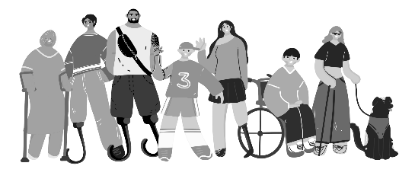 |  | National Disability Voting Rights Week | ECI Board Meeting  @ ECI  1:00pm – 3:00pm |  |  | Youth ILS Training  Community & Advocacy  @ ECI  1:30pm – 3:00pm
17 | 18 | 19 | 20 | 21 | 22 | 23
ILS Training:
Time Use

@ ECI
2:00pm – 3:30pm

24 | 25 | 26 | 27 | 28 | 29 | 30
Deaf Awareness Event*

@ Crossroads
2:00pm – 3:30pm

September 2023

Disability Advocacy & Services

Endependence Center, Inc.
6300 East Virginia Beach Blvd
Norfolk, VA 23502

Phone:
(757) 461-8007 Voice
(757) 461-7527 TDD

E-Mail:

ecinorf@endependence.org

Website:

www.endependence.org

Newsletter alternate format:
contact (757) 351-1598 or ehoapili@endependence.org

Schedule Changes
Check the ECI website: www.endependence.org
or call
(757) 461-8007, option 4

ELECTRONIC SERVICE REQUESTED

Accommodations
To request accommodations
for ECI activities:
(757) 351-1586 voice
(757) 461-7527 TDD
tmanno@endependence.org

Non-Profit Org.
U.S. Postage
PAID
Norfolk, VA
Permit No. 102

Place label here

Social Media
Facebook: Endependence Center, Inc.-Norfolk, Virginia

