ENDEPENDENCE CENTER NEWSLETTER OCTOBER 2023

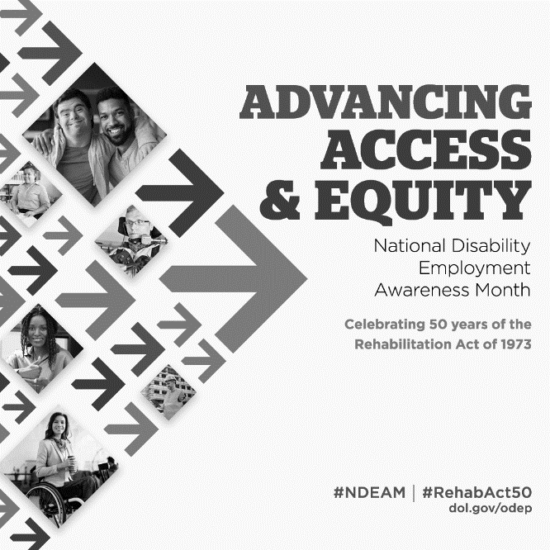
October is National Disability Employment Awareness Month
Held annually, National Disability Employment Awareness Month celebrates the many contributions of America's workers with disabilities. This year's theme is "Advancing Access and Equity."

In 2022, about 21 percent of people with a disability in the U.S. were employed, up from about 19 percent in 2021, according to the U.S. Bureau of Labor Statistics (BLS). This is still an incredibly low number. But, as we work together to support the employment goals of people with disabilities, these numbers can only grow.

ECI offers employment support to persons with disabilities via the Ticket to Work program, as well as benefits counseling. For more information, visit our website at http://www.endependence.org.

"National Disability Employment Awareness Month reminds us of the valued contributions people with disabilities make in our nation’s workplaces, and the 50th anniversary of the Rehabilitation Act of 1973 marks a major milestone in our nation’s ongoing quest to advance access and equity for all Americans.” - Assistant Secretary for Disability Employment Policy, Taryn M. Williams.

Voter Registration Information

Election Day is November 7. For more information and to make a plan to vote, visit https://www.elections.virginia.gov/.

IFSP Funding Announcement
Beginning Monday, October 16, individuals on Virginia's Medicaid Developmental Disability Waivers Waiting List will be able to access the Individual and Family Support Program (IFSP) Funding Portal to submit an application. Applications will be available until November 14 at 5:00pm. There will also be virtual trainings to assist individuals and families completing applications. REGISTRATION IS REQUIRED. For more details, visit https://dbhds.virginia.gov/developmental-services/ifsp/.
OCTOBER 2023

Endependence Center, Inc. Events
Held at ECI, 6300 E. Virginia Beach Blvd, Norfolk

4TH Consumer Advisory Committee (CAC) 2:00pm – 3:30pm
WED Agenda is to review the results of the CAC participant satisfaction survey and discuss recommendations to the ECI Board.

17TH Back to School Information Session 6:30pm – 7:30pm
TUE For youth and young adults with disabilities, parents, and special education stakeholders to learn about programs and supports for transition-age youth. The following topics will be covered: VBThrive; Medicaid home and community-based waivers for support; employment services; and transition services.

18TH Independent Living Skills Training: Goal Setting 2:00pm – 3:30pm
WED By recording your dreams and goals on paper, you set in motion the process of becoming the person you want to be. Goal setting refers to the process of setting specific, attainable targets. Learn why goal setting is so important in life and how to do it.

21ST Youth Independent Living Skills Training: Handling Stress and
SAT Communication Skills 1:30pm – 3:00pm
Learn about how to manage stress and communicate with others.

25TH Advocacy Group 2:00pm – 3:30pm
WED Planning for advocacy to address program access issues with local government programs.

Community Events & News
Transportation tickets are NOT provided to attend community events.

6TH Silent Dinner 5:00pm – 8:00pm
FRI Lynnhaven Mall (701 Lynnhaven Parkway, Virginia Beach)
Southside Silent Dinner is a silent, social, family-friendly event for the deaf community, CODA (Child of Deaf Adult), ASL beginners and students, and others interested in ASL.

17TH Participant-Led Event 12noon – 2:30pm
TUES Smokey Bones (4590 Virginia Beach Blvd., Virginia Beach)
This event is organized by participants.

Reminder:
If you haven't yet, don't forget to complete your Consumer Satisfaction Survey received via mail or email. If you have not received a survey, visit endependence.org/feedback.

SUNDAY | MONDAY | TUESDAY | WEDNESDAY | THURSDAY | FRIDAY | SATURDAY
1 | 2 | 3 | 4 | 5 | 6 | 7
 |  |  | Consumer Advisory Committee  @ ECI  2:00pm – 3:30pm |  | Silent Dinner*  @ Lynnhaven Mall  5:00pm – 8:00pm
8 | 9 | 10 | 11 | 12 | 13 | 14
ECI CLOSED
IN OBSERVANCE OF
COLUMBUS DAY
15 | 16 | 17 | 18 | 19 | 20 | 21
 |  | Back to School Information Session  @ ECI  6:30pm – 7:30pm  ***  Participant-Led Event*  @ Smokey Bones, Virginia Beach  12noon – 2:30pm | ILS Training:  Goal Setting  @ ECI  2:00pm – 3:30pm |  |  | Youth ILS Training  Handling Stress & Communication Skills  @ ECI  1:30pm – 3:00pm
22 | 23 | 24 | 25 | 26 | 27 | 28
Advocacy Group

@ ECI
2:00pm – 3:30pm

29 | 30 | 31
 |  |  |  |  |  | *These events are not organized by ECI. Bus and paratransit tickets will not be provided by ECI.

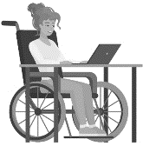
October 2023
National Disability Employment Awareness Month

Disability Advocacy & Services

Endependence Center, Inc.
6300 East Virginia Beach Blvd
Norfolk, VA 23502

Phone:
(757) 461-8007 Voice
(757) 461-7527 TDD

E-Mail:

ecinorf@endependence.org

Website:

www.endependence.org

Newsletter alternate format:
contact (757) 351-1598 or ehoapili@endependence.org

Schedule Changes
Check the ECI website: www.endependence.org
or call
(757) 461-8007, option 4

ELECTRONIC SERVICE REQUESTED

Accommodations
To request accommodations
for ECI activities:
(757) 351-1586 voice
(757) 461-7527 TDD
tmanno@endependence.org

Non-Profit Org.
U.S. Postage
PAID
Norfolk, VA
Permit No. 102

Place label here

Social Media
Facebook: Endependence Center, Inc.-Norfolk, Virginia

