ENDEPENDENCE CENTER NEWSLETTER DECEMBER 2023

Annual Participant Holiday Party – see page 2

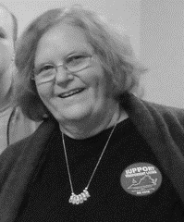
ECI Honors Cheryl Simpson for 40 Years of Service
A message from ECI Executive Director, Nichole Davis

Cheryl Simpson has been vital to the Endependence Center for the past 40 years. Though we are sad to see her retire, we can say that she was a critical part of the Endependence Center and will be missed. It is hard to imagine a time when she was not around to have the answer to operational questions, resolve a technology issue, or answer any question about programs Endependence Center provides that help support people with disabilities with obtaining employment, as well as help advocate and ensure that when emergency planning happens, people with disabilities are a part of those conversations. Cheryl Simpson was around when Endependence Center was starting, and helped see it grow and be part of how Endependence Center has impacted the Tidewater community. Throughout her time here, the Endependence Center has grown from a staff of less than 10 to over 25. She was an employee who believed in the mission and vision of the Endependence Center, but also understood how vital operations and support were to ensure that all the various grants, programs, and services that helped meet the mission happened. It was not unusual that when a staff member had a question about a programmatic or operational need, “ask Cheryl” was a standard answer. ECI is sad to see her go, but after 40 years of HARD WORK, we wish her a Happy Retirement.

ECI Mailing List Updates
ECI is updating the newsletter mailing list. Participants working on goals will remain on the mailing list; you do not need to do anything. Everyone else – please let us know by December 5 if you want to continue receiving the newsletter (we hope you do!). Send an email to kmarinier@endependence.org or call 757-351-1569 if you want to continue receiving the newsletter. Please leave a message with your name and request to remain on the mailing list. If you now receive a mailed copy of the newsletter and would prefer to receive it by email, please provide your email address in the message.

DECEMBER 2023

Annual Participant Holiday Party
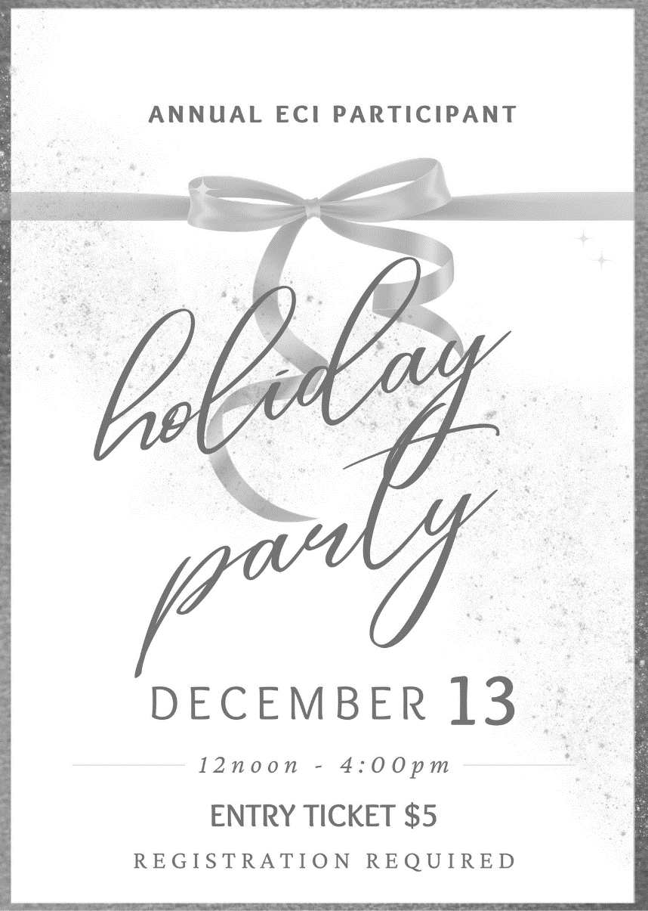
December 13, 2023
12noon – 4:00pm
Doubletree by Hilton Norfolk
1500 N. Military Highway, Norfolk

The party is open to CENTER PARTICIPANTS only.
Participants may register one guest for $5.

REGISTRATION IS REQUIRED. Register by December 6.
Call 757-461-8007 (TDD: 461-7527)

The cost is $5.00 per person and payable at the door by cash, check, or debit or credit card.
Music, Pictures, Karaoke, Dancing, and Door Prizes
Menu: Mediterranean Chicken entrée with side salad (vegetarian option available upon request)

You are encouraged to be responsible for your own transportation to and from the party.

Community Events & News
Transportation tickets are NOT provided to attend community events.

1ST Silent Dinner 5:00pm – 8:00pm
FRI Lynnhaven Mall (701 Lynnhaven Parkway, Virginia Beach)
Southside Silent Dinner is a silent, social, family-friendly event for the deaf community, CODA (Child of Deaf Adult), ASL beginners and students, and others interested in ASL.

19th Participant-Led Event 12noon – 2:30pm
FRI Buffalo Wild Wings (420 Monticello Ave., Suite 150, Norfolk)
This event is organized by participants.

SUNDAY | MONDAY | TUESDAY | WEDNESDAY | THURSDAY | FRIDAY | SATURDAY
 |  |  |  |  | 1 | 2
*These events are not organized by ECI. Bus and paratransit tickets will not be provided by ECI. |  |  |  |  | Silent Dinner*  @ Lynnhaven Mall  5:00pm – 8:00pm
3 | 4 | 5 | 6 | 7 | 8 | 9
 |  |  |  | ECI CLOSED FOR STAFF EVENT
10 | 11 | 12 | 13 | 14 | 15 | 16
Participant Holiday Party

@ Hilton, Norfolk
12noon – 4:00pm

ECI OFFICE CLOSED
17 | 18 | 19 | 20 | 21 | 22 | 23
 |  | Participant-Led Event*  @ Buffalo Wild Wings, Norfolk  12noon – 2:30pm |  |  | ECI CLOSED IN OBSERVANCE OF HOLIDAY
24 | 25 | 26 | 27 | 28 | 29 | 30
 | ECI CLOSED IN OBSERVANCE OF HOLIDAY

December 2023

Disability Advocacy & Services

Endependence Center, Inc.
6300 East Virginia Beach Blvd
Norfolk, VA 23502

Phone:
(757) 461-8007 Voice
(757) 461-7527 TDD

E-Mail:

ecinorf@endependence.org

Website:

www.endependence.org

Newsletter alternate format:
contact (757) 351-1598 or ehoapili@endependence.org

Schedule Changes
Check the ECI website: www.endependence.org
or call
(757) 461-8007, option 4

ELECTRONIC SERVICE REQUESTED

Accommodations
To request accommodations
for ECI activities:
(757) 351-1586 voice
(757) 461-7527 TDD
tmanno@endependence.org

Non-Profit Org.
U.S. Postage
PAID
Norfolk, VA
Permit No. 102

Place label here

Social Media
Facebook: Endependence Center, Inc.-Norfolk, Virginia

