ENDEPENDENCE CENTER NEWSLETTER NOVEMBER 2023

ECI Launches New Independent Living Skills Training Series: What's Bugging You?
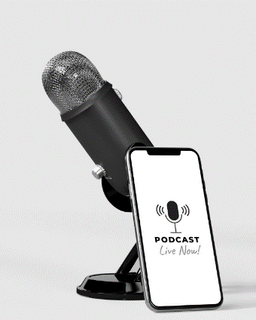
ECI is launching a new Independent Living Skills series focused around podcasts. This series, "What's Bugging You?" will be held the last Wednesday of the month.
Podcasts have taken off in the past few years. They are a way in which people can learn, laugh, keep up with current events, and discuss areas of interest. Come join ECI staff as we explore what and why so many people are listening to and creating podcasts.
This month, we will explore one short podcast about disability barriers and discuss if the solutions to those barriers are being discussed.
Our goal is learn about the current podcasts that exist, and then work to create our own participant-driven podcast to focus on potential solutions to what's bugging us. For more information, email Nichole Davis at ndavis@endependence.org.
Save the Date – ECI Holiday Party
Mark your calendars! This year's holiday party will be held on Wednesday, December 13 from 12noon – 4:00pm in Norfolk.
Become a Disability A.L.L.Y. in Your Community
Disability affects nearly 1 in 4 (26%) adults in the United States. Every community member can make a difference and play a part in identifying barriers that potentially impact people with disabilities. For more information to address those barriers and increase disability inclusion in your community, visit https://www.cdc.gov/ncbddd/humandevelopment/become-a-disability-ALLY.html
ECI Mailing List Updates
ECI is updating the newsletter mailing list. Participants working on goals will remain on the mailing list; you do not need to do anything. Everyone else – please let us know by December 5 if you want to continue receiving the newsletter (we hope you do!). Send an email to kmarinier@endependence.org or call 757-351-1569 if you want to continue receiving the newsletter. Please leave a message with your name and request to remain on the mailing list. If you now receive a mailed copy of the newsletter and would prefer to receive it by email, please provide your email address in the message.
NOVEMBER 2023

Endependence Center, Inc. Events
Held at ECI, 6300 E. Virginia Beach Blvd, Norfolk

8TH ECI Board of Directors Meeting 1:00pm – 3:00pm
WED ECI Board meetings are open to the public.

15TH Independent Living Skills Training: Social Safety 2:00pm – 3:30pm
WED Protecting yourself when using social media.

18TH Youth Independent Living Skills Training 1:30pm – 3:00pm
SAT Time for a reunion! This month, past participants of the summer program YEA! (Youth Endependent Advocates) come together to discuss goal progress and develop topics for next year.

29TH Independent Living Skills Training: What's Bugging You? 2:00pm – 3:30pm
WED See page 1 for more details.

Community Events & News
Transportation tickets are NOT provided to attend community events.

3RD Silent Dinner 5:00pm – 8:00pm
FRI Lynnhaven Mall (701 Lynnhaven Parkway, Virginia Beach)
Southside Silent Dinner is a silent, social, family-friendly event for the deaf community, CODA (Child of Deaf Adult), ASL beginners and students, and others interested in ASL.

18TH TOUCH Group 11:00am – 1:00pm
SAT ECI (6300 E. Virginia Beach Blvd., Norfolk)
Come out and join the TOUCH Group for good conversation, networking and entertainment. Individuals with a disability are important to us, so come be part of a great group of people and meet new friends from your community. Your friends and family are invited also, to learn and ask questions about disabilities in their community.

21st Participant-Led Event 12noon – 2:30pm
TUES Golden Corral Buffet and Grill (101 Volvo Parkway, Chesapeake)
This event is organized by participants.
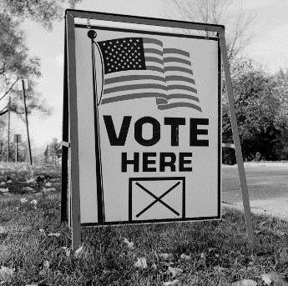
HRT: Free Fares on Election Day
On Election Day, November 7, fares for bus, light rail, ferry, and paratransit are FREE. For more information, visit http://www.gohrt.com/alert/virginia-election-day-free-fare/.

SUNDAY | MONDAY | TUESDAY | WEDNESDAY | THURSDAY | FRIDAY | SATURDAY
 |  |  | 1 | 2 | 3 | 4
Silent Dinner*

@ Lynnhaven Mall
5:00pm – 8:00pm
5 | 6 | 7 | 8 | 9 | 10 | 11
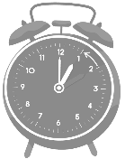  DAYLIGHT SAVINGS TIME ENDS |  |  | ECI Board Meeting  @ ECI  1:00pm – 3:00pm |  | ECI CLOSED IN OBSERVANCE OF VETERAN'S DAY
12 | 13 | 14 | 15 | 16 | 17 | 18
 |  |  | ILS Training: Social Safety  @ ECI  2:00pm – 3:30pm |  |  | TOUCH Group*  @ ECI  11:00am – 1:00pm  Youth ILS Training  YEA! Summer Program Reunion  @ ECI  1:30pm – 3:00pm
19 | 20 | 21 | 22 | 23 | 24 | 25
 |  | Participant-Led Event*  @Golden Corral, Chesapeake  12noon – 2:30pm | ECI CLOSING AT 12noon | ECI CLOSED IN OBSERVANCE OF THANKSGIVING | ECI CLOSED
26 | 27 | 28 | 29 | 30
 |  |  | ILS Series:  What's Bugging You?  @ ECI  2:00pm – 3:30pm |  |  | *These events are not organized by ECI. Bus and paratransit tickets will not be provided by ECI.

November 2023

Disability Advocacy & Services

Endependence Center, Inc.
6300 East Virginia Beach Blvd
Norfolk, VA 23502

Phone:
(757) 461-8007 Voice
(757) 461-7527 TDD

E-Mail:

ecinorf@endependence.org

Website:

www.endependence.org

Newsletter alternate format:
contact (757) 351-1598 or ehoapili@endependence.org

Schedule Changes
Check the ECI website: www.endependence.org
or call
(757) 461-8007, option 4

ELECTRONIC SERVICE REQUESTED

Accommodations
To request accommodations
for ECI activities:
(757) 351-1586 voice
(757) 461-7527 TDD
tmanno@endependence.org

Non-Profit Org.
U.S. Postage
PAID
Norfolk, VA
Permit No. 102

Place label here

Social Media
Facebook: Endependence Center, Inc.-Norfolk, Virginia

