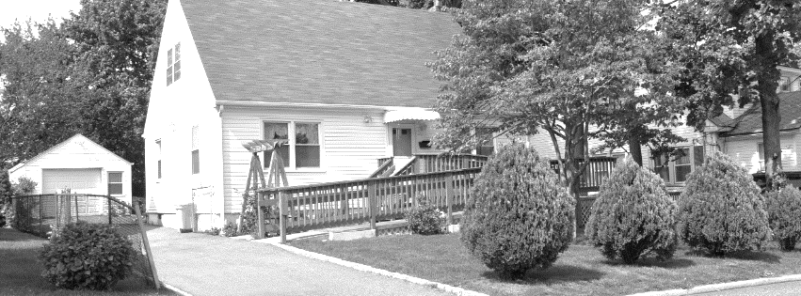
ENDEPENDENCE CENTER NEWSLETTER APRIL 2024
Pictured above: A white house with a driveway. A wheelchair-accessible ramp leads from the driveway to the front door.
April is Fair Housing Month
Vantoria Clay, ECI’s Housing Advocacy Coordinator, will present on the Federal Fair Housing Law at this month’s Advocacy Group on Wednesday, April 24 at 2:00pm. Topics to cover include illegal practices in the sale and rental of housing, disability protections, and the complaint process. Please bring your questions.

ECI Partners with disAbility Law Center of Virginia for Voting Rights Presentation
On April 9 at 10:00am at ECI, the disAbility Law Center of Virginia will present on voting rights for individuals with disabilities. Some key considerations include: legal protections, accessibility at polling places, accessible voting materials, and assistance and accommodations.
After the presentation, people with disabilities can request a private 30-minute consultation with the disAbility Law Center of Virginia about voting rights. To schedule a 30-minute consultation, please email Joliefawn.Liddell@dlcv.org. To request disability accommodations, please contact tmanno@endependence.org or 757-351-1586.
Pictured above: a ballot and voting sticker are handed to a man standing next to a person using a wheelchair.

Upcoming Open House Workshops for Public Health Organizations
ECI will host a free, hour-long open house workshop for public health organizations to discuss ECI services, the Independent Living philosophy, effective communication techniques for interacting with people with disabilities, access in medical settings and T.A.P., transitioning from nursing facilities, and housing, and to provide networking opportunities.

In April, the workshop will be held on April 25 at 4:00pm – 5:00pm at ECI. No prior registration required. For questions, contact Benjamin White at 757-351-1583 or bwhite@endependence.org.
April 2024
Endependence Center, Inc. Events
Held at ECI, 6300 E. Virginia Beach Blvd, Norfolk

9th Voting Rights for Persons with Disabilities 10:00am – 11:00am
TUE See page 1 for details.

10th Consumer Advisory Committee (CAC) 2:00pm – 3:30pm
WED Agenda is to recap Independent Living Day.

17th Independent Living Skills Training
WED What is On Your Plate or In Your Cup? 2:00pm – 3:30pm
Come and find out how the choices on your plate or in your cup can be impacting your health and discuss how and where to find ways of making your food and drink choices part of a preventative healthcare plan.

24TH Advocacy Group 2:00pm – 3:30pm
WED This month’s topic is Fair Housing. See page 1 for details.

27th Youth Independent Living Skills Training 1:30pm – 3:00pm
SAT Transportation/Driving

30th Independent Living Skills Training on Podcasts
TUE What’s Bugging You? 3:00pm – 4:30pm
This month, we’ll write the podcast and prepare it for recording.

Community Events
Transportation tickets are NOT provided to attend community events.

5th Silent Dinner 5:30pm – 8:00pm
FRI Lynnhaven Mall (701 Lynnhaven Parkway, Virginia Beach)
Southside Silent Dinner is a silent, social, family-friendly event for the deaf community, CODA (Child of Deaf Adult), ASL beginners and students, and others interested in ASL.

13th ASL Hangout 5:00pm – 9:00pm
SAT Ozzlefinch Beers and Blending (81 Patch Road, Fort Monroe)
The ASL Hangout goal is to bring deaf, hard of hearing, and hearing people together to socialize and expand the ASL/deaf community. All users of sign language, any level, are welcome!

16th Participant-Led Event 12noon – 2:30pm
TUE Norfolk Premium Outlets (1600 Premium Outlets Blvd., Norfolk)
This event is organized by participants.

27th TOUCH Group 12:30pm – 2:30pm
SAT Pin Boys at the Beach (1577 Laskin Road, Virginia Beach)
Come and enjoy fun, food and friendly competition among your peers! The T.O.U.C.H would like to announce its 2nd annual bowling event. Bowling spots will be limited, please RSVP or contact for more details with Montrell Rodgers or April Harrington (phone: (757)-238-1293, (757)-828-9702 or email: vatouch.22@gmail.com)

SUNDAY | MONDAY | TUESDAY | WEDNESDAY | THURSDAY | FRIDAY | SATURDAY
 | 1 | 2 | 3 | 4 | 5 | 6
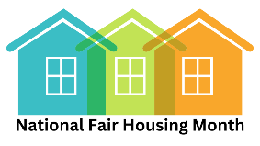 |  |  |  |  | Silent Dinner*  @ Lynnhaven Mall  5:30pm – 8:00pm
7 | 8 | 9 | 10 | 11 | 12 | 13
 |  | dLCV Presentation  @ ECI  10:00am – 11:00am | Consumer Advisory Committee (CAC)  @ ECI  2:00pm – 3:30pm | ECI CLOSED 12noon – 2:00pm FOR STAFF MEETING |  | ASL Hangout*  @ Ozzlefinch Beers and Blending  5:00pm – 9:00pm
14 | 15 | 16 | 17 | 18 | 19 | 20
 |  | Participant-Led Event*  @ Norfolk Premium Outlets  12noon – 2:30pm | ILS Training  “What’s On Your Plate and In Your Cup?”  @ ECI  2:00pm – 3:30pm
21 | 22 | 23 | 24 | 25 | 26 | 27
 |  |  | Advocacy Group  @ ECI  2:00pm - 3:30pm | Public Health Open House  @ ECI  4:00pm – 5:00pm |  | Youth ILS Training  @ ECI  2:00pm – 3:30pm  TOUCH Group  @ ECI  11:00am – 1:00pm
28 | 29 | 30
 |  | ILS Training: “What’s Bugging You?”  @ ECI  3:00pm – 4:30pm |  |  | *These events are not organized by ECI. Bus and paratransit tickets will not be provided by ECI.

April 2024

Disability Advocacy & Services

Endependence Center, Inc.
6300 East Virginia Beach Blvd
Norfolk, VA 23502

Phone:
(757) 461-8007 Voice
(757) 461-7527 TDD

E-Mail:

ecinorf@endependence.org

Website:

www.endependence.org

Newsletter alternate format:
contact (757) 351-1598 or ehoapili@endependence.org

Schedule Changes
Check the ECI website: www.endependence.org
or call
(757) 461-8007, option 4

ELECTRONIC SERVICE REQUESTED

Accommodations
To request accommodations
for ECI activities:
(757) 351-1586 voice
(757) 461-7527 TDD
tmanno@endependence.org

Non-Profit Org.
U.S. Postage
PAID
Norfolk, VA
Permit No. 102

Place label here

Social Media
Facebook: Endependence Center, Inc.-Norfolk, Virginia

