ENDEPENDENCE CENTER NEWSLETTER MARCH 2024

Independent Living Day at the General Assembly Wrap-Up
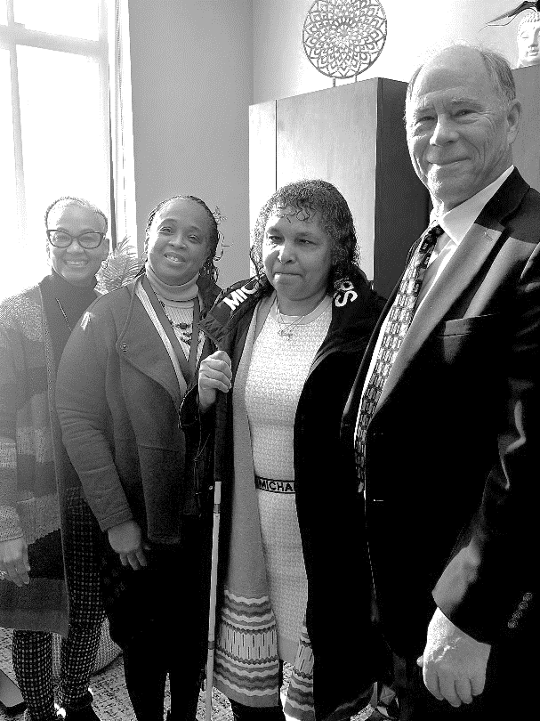
ECI participants, board members, and staff traveled to Richmond last month for Independent Living Day at the General Assembly. They met with legislators to discuss issues important to people with disabilities.

Discussions this year centered around opposing legislation that would legalize assisted suicide, increasing Medicaid personal care rates, and increasing funding to allow CILs to maintain services.

For updates on The Virginia Association of Centers for Independent Living (VACIL) legislative priorities, see the ECI website or Facebook page.

Pictured left: ECI attendees of IL Day with Lisa Barnes, Chief of Staff for Delegate Convirs-Fowler

ECI Partners with disAbility Law Center of Virginia for Presentation on Healthcare

Private thirty-minute consultations available after presentations
On March 5 at 10:00am at ECI, the disAbility Law Center of Virginia will present on the importance of, and your rights to, effective communication and accessibility in healthcare for individuals. Some key considerations include:
- Healthcare facilities should prioritize physical and digital accessibility for individuals with disabilities, such as wheelchair ramps, accessible restrooms, and websites compatible with assistive technologies; and
- Healthcare providers should be knowledgeable about and utilize various communication aids, such as sign language interpreters, communication boards, or speech-to-text applications, based on the specific needs of each individual.

After the presentation, people with disabilities can request a private 30-minute consultation with the disAbility Law Center of Virginia about effective communication and accessibility in healthcare and voting rights. To schedule a 30-minute consultation, please email Joliefawn.Liddell@dlcv.org. To request disability accommodations for the presentations below, please contact tmanno@endependence.org or 757-351-1585.
MARCH 2024
Endependence Center, Inc. Events
Held at ECI, 6300 E. Virginia Beach Blvd, Norfolk

5th Effective Communication & Accessibility in Healthcare for People with Disabilities
TUE 10:00am – 11:00am.
See page 1 for details.

13th Board of Directors Meeting 1:00pm – 3:00pm
WED ECI Board of Directors meetings are open to the public.

16th Youth Independent Living Skills Training 1:30pm – 3:00pm
SAT How to Get a Job Workshop

20th Independent Living Skills Training: Bystander CPR 2:00pm – 3:30pm
WED Bystander CPR is a hands-only version of CPR. Attendees will learn both how to perform Bystander CPR and instruct others to do so. This ILS will be taught by EVMS students.

26th NEW DATE AND TIME! Independent Living Skills Training on Podcasts
TUE What's Bugging You? 3:00pm – 4:30pm
This month we'll learn more about and practice using podcast equipment.

27th Advocacy Group 2:00pm – 3:30pm
WED Review of ADA Title II, State and Local Government Provisions

Community Events & News
Transportation tickets are NOT provided to attend community events.

1ST Silent Dinner 5:30pm – 8:00pm
FRI Lynnhaven Mall (701 Lynnhaven Parkway, Virginia Beach)
Southside Silent Dinner is a silent, social, family-friendly event for the deaf community, CODA (Child of Deaf Adult), ASL beginners and students, and others interested in ASL.

19th Participant-Led Event 12noon – 2:30pm
TUE The Twisted Crab (420 Monticello Ave, Suite 13D, Norfolk)
This event is organized by participants.

16th TOUCH Group 11:00am – 1:00pm
SAT ECI (6300 E. Virginia Beach Blvd., Norfolk)
Join us for positive insight and networking. Take this opportunity to create new connections and sharing ideas with others who also have a disability in your community. Your disability is important to us, so lets talk about it.

ECI Media Room is Re-Opening!
The ECI Media Room will re-open March 1, providing a space with internet and phone access and a computer with adaptive equipment. This space can be used for up to two hours and is open Monday – Friday, 9:30am – 4:00pm. Availability is not guaranteed, and reservations are encouraged. For more information or to reserve the room, contact your ECI Coordinator.

SUNDAY | MONDAY | TUESDAY | WEDNESDAY | THURSDAY | FRIDAY | SATURDAY
 |  |  |  |  | 1 | 2
 |  | *These events are not organized by ECI. Bus and paratransit tickets will not be provided by ECI. |  |  | Silent Dinner*  @ Lynnhaven Mall  5:30pm – 8:00pm
3 | 4 | 5 | 6 | 7 | 8 | 9
 |  | dLCV Presentation  @ ECI  10:00am – 11:00am |  |  |  | ASL Hangout*  @ Wasserhund Brewing  6:00pm – 9:00pm
10 | 11 | 12 | 13 | 14 | 15 | 16
 |  |  | Board of Directors Meeting  @ ECI  1:00pm – 3:00pm |  |  | Youth ILS Training  @ ECI  1:30pm – 3:00pm  TOUCH Group  @ ECI  11:00am – 1:00pm
17 | 18 | 19 | 20 | 21 | 22 | 23
 |  | Participant-Led Event*  @ The Twisted Crab  12noon – 2:30pm | ILS Training  "Bystander CPR"  @ ECI  2:00pm – 3:30pm
24  31 | 25 | 26 | 27 | 28 | 29 | 30
 |  | *NEW DATE!*  ILS Training  "What's Bugging You?"  @ ECI  2:00pm – 3:30pm | Advocacy Group  @ ECI  2:00pm – 3:30pm

March 2024

Disability Advocacy & Services

Endependence Center, Inc.
6300 East Virginia Beach Blvd
Norfolk, VA 23502

Phone:
(757) 461-8007 Voice
(757) 461-7527 TDD

E-Mail:

ecinorf@endependence.org

Website:

www.endependence.org

Newsletter alternate format:
contact (757) 351-1598 or ehoapili@endependence.org

Schedule Changes
Check the ECI website: www.endependence.org
or call
(757) 461-8007, option 4

ELECTRONIC SERVICE REQUESTED

Accommodations
To request accommodations
for ECI activities:
(757) 351-1586 voice
(757) 461-7527 TDD
tmanno@endependence.org

Non-Profit Org.
U.S. Postage
PAID
Norfolk, VA
Permit No. 102

Place label here

Social Media
Facebook: Endependence Center, Inc.-Norfolk, Virginia

