ENDEPENDENCE CENTER NEWSLETTER MAY 2024

Registration Now Open for Summer Youth Program, Youth Endependent Advocates (YEA!)
ECI's Youth Endependent Advocates (YEA!) is a summer program with interactive events for youth with disabilities to learn skills, understand their rights, and socialize with others (schedule below). Participants must be referred by a Department for Aging and Rehabilitative Services (DARS) counselor and pre-registration is required. Acceptance into the summer program is based on a first-come, first-served basis after a referral is received from DARS. For information, contact Sarah Cook, scook@endependence.org, 757-351-1585.

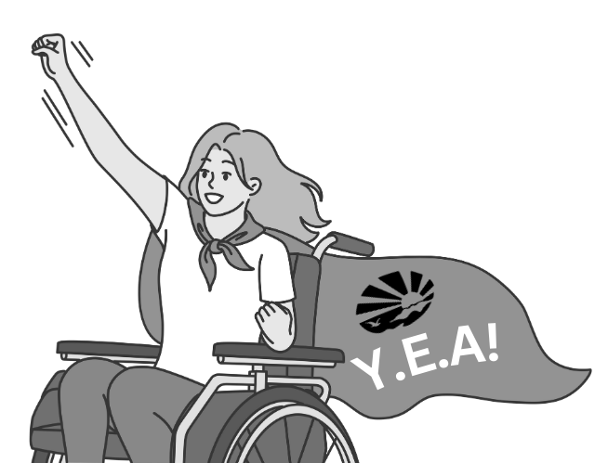
WHO: Youth with disabilities, ages 16-21 (must still be in school). Participants should be motivated to be involved in activities and interested in learning and sharing.
WHEN: July 8 – August 1, Monday through Thursday, 1:00pm – 5:00pm daily
WHERE: Endependence Center, with a community outing on Tuesdays.
TRANSPORTATION: Participants will arrange their own transportation. Paratransit and bus tickets are provided.
Disability accommodations are provided.

Upcoming Open House Workshop for Public Health Organizations
ECI will host a free, hour-long open house workshop for public health organizations to discuss ECI services, the Independent Living philosophy, effective communication techniques for interacting with people with disabilities, access in medical settings, the Technology Assistance Program, transitioning from nursing facilities, housing, and to provide networking opportunities.

The workshop will be held on May 22 at 4:00pm – 5:00pm at ECI. No prior registration required. For questions, contact Benjamin White at 757-351-1583 or bwhite@endependence.org.

ECI Media Room is Open!
The ECI Media Room re-opened in March, providing a space with internet and phone access and a computer with adaptive equipment. This space can be used for up to two hours and is open Monday – Friday, 9:30am – 4:00pm. Availability is not guaranteed, and reservations are encouraged. For more information or to reserve the room, contact your ECI Coordinator.
May 2024
Endependence Center, Inc. Events
Held at ECI, 6300 E. Virginia Beach Blvd, Norfolk

8th Board of Directors Meeting 1:00pm – 3:00pm
WED ECI Board of Directors meetings are open to the public.

15th Independent Living Training: Maintaining Mental Health During Mental Health
WED Awareness Month 2:00pm – 3:30pm
We will be discussing community resources and what we can incorporate in our daily lives to maintain our mental health. Join us as we discuss how we work through the “Moody Mondays” and get to the “Fabulous Fridays."

18th Youth Independent Living Skills Training 1:30pm – 3:00pm
SAT How to Navigate the Internet, Social Media, and Other Computer Skills

28th Independent Living Skills Training on Podcasts
TUE What's Bugging You? 3:00PM – 4:30PM
This month, we'll record and edit our first episode.

29th Advocacy Group: Title III Accommodations 2:00pm – 3:30pm
WED Discussion this month will surround Title III of the Americans with Disabilities Act, which covers discrimination against individuals with disabilities in places of public accommodation.

Community Events & News
Transportation tickets are NOT provided to attend community events.

3rd Silent Dinner 5:30pm – 8:00pm
FRI Lynnhaven Mall (701 Lynnhaven Parkway, Virginia Beach)
Southside Silent Dinner is a silent, social, family-friendly event for the deaf community, CODA (Child of Deaf Adult), ASL beginners and students, and others interested in ASL.

4th ASL Hangout 11:00am – 8:00pm
SAT Bayville Farms Park (4132 First Ct Rd, Virginia Beach)
The ASL Hangout goal is to bring deaf, hard of hearing, and hearing people together to socialize and expand the ASL/deaf community. All users of sign language, any level, are welcome!

18th TOUCH Group: Empowering Disabled Women in Our Community
SAT 11:00am – 1:00pm
ECI (6300 E. Virginia Beach Blvd., Norfolk)
Join the women of the TOUCH Group for great conversation on battling barriers as a disabled woman in our community.

21st Participant-Led Event 12noon – 2:30pm
TUE Ruby Tuesday (1201 N. Military Highway, Norfolk)
This event is organized by participants.

SUNDAY | MONDAY | TUESDAY | WEDNESDAY | THURSDAY | FRIDAY | SATURDAY
 |  |  | 1 | 2 | 3 | 4
 | *These events are not organized by ECI. Bus and paratransit tickets will not be provided by ECI. |  |  |  | Silent Dinner*  @ Lynnhaven Mall  5:30pm – 8:00pm | ASL Hangout*  @ Bayville Farms Park  11:00am – 8:00pm
5 | 6 | 7 | 8 | 9 | 10 | 11
 |  |  | Board of Directors Meeting  @ ECI  1:00pm – 3:00pm | ECI CLOSED FOR STAFF EVENT
12 | 13 | 14 | 15 | 16 | 17 | 18
 |  |  | ILS Training  "Maintaining Mental Health"  @ ECI  2:00pm – 3:30pm |  |  | TOUCH Group*  @ ECI  11:00am – 1:00pm  Youth ILS Training  @ ECI  1:30pm – 3:00pm
19 | 20 | 21 | 22 | 23 | 24 | 25
 |  | Participant-Led Event*  @ ECI  12noon – 2:30pm | Public Health Open House  @ ECI  4:00pm – 5:00pm | ECI CLOSED FOR STAFF EVENT
26 | 27 | 28 | 29 | 30 | 31
 | ECI CLOSED IN OBSERVANCE  OF MEMORIAL DAY | ILS Training: "What's Bugging You?"  @ ECI  3:00pm – 4:30pm | Advocacy Group  @ ECI  2:00pm – 3:30pm

May 2024

Disability Advocacy & Services

Endependence Center, Inc.
6300 East Virginia Beach Blvd
Norfolk, VA 23502

Phone:
(757) 461-8007 Voice
(757) 461-7527 TDD

E-Mail:

ecinorf@endependence.org

Website:

www.endependence.org

Newsletter alternate format:
contact (757) 351-1598 or ehoapili@endependence.org

Schedule Changes
Check the ECI website: www.endependence.org
or call
(757) 461-8007, option 4

ELECTRONIC SERVICE REQUESTED

Accommodations
To request accommodations
for ECI activities:
(757) 351-1586 voice
(757) 461-7527 TDD
tmanno@endependence.org

Non-Profit Org.
U.S. Postage
PAID
Norfolk, VA
Permit No. 102

Place label here

Social Media
Facebook: Endependence Center, Inc.-Norfolk, Virginia

