ENDEPENDENCE CENTER NEWSLETTER JUNE 2024

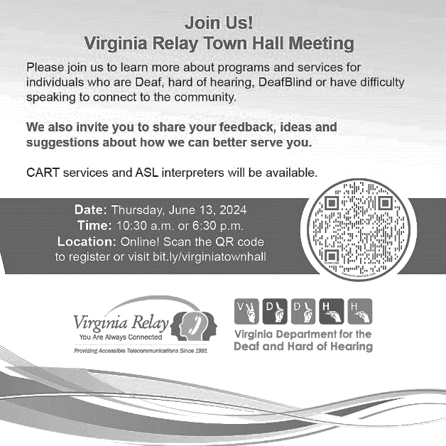
Mark Your Calendars! Virginia Relay to Hold June Town Hall Meetings
Join Virginia Relay on Thursday, June 13 at 10:30am or 6:30pm to learn more about programs and services for individuals who are Deaf, hard of hearing, DeafBlind, or have difficulty speaking to connect to the community. Attendees are also invited to share feedback, ideas, and suggestions. CART services and ASL interpreters will be available. PRE-REGISTRATION IS REQUIRED. To register, visit http://bit.ly/virginiatownhall or use the QR code on the right.

Families & Professionals Interested in Special Education – Let Your Voice Be Heard!
The 2024 General Assembly mandated that the Commission on Youth, a bipartisan legislative commission of the General Assembly, conduct a study on how to improve Virginia's special education dispute resolution processes to present to the 2025 General Assembly. The Commission is collaborating with Parent Educational Advocacy Training Center (PEATC) to hold listening sessions to hear from family members and professionals who have been involved with the special education dispute resolution system or have perspectives to share.
The Virtual Session will be held on June 20 at 6:00pm until 8:00pm. ECI is hosting the in-person listening session for the Hampton Roads area on June 27 at 6:00pm until 8:00pm. PRE-REGISTRATION IS REQUIRED. To register, visit http://bit.ly/3Ka5a91 or scan the QR code on the left. More information can be found on the ECI website.

Reminder: Registration Open for YEA!
ECI's Youth Endependent Advocates (YEA!) is a summer program with interactive events for youth with disabilities to learn skills, understand their rights, and socialize with others (schedule below). Participants must be referred by a Department for Aging and Rehabilitative Services (DARS) counselor and pre-registration is required. Acceptance is based on a first-come, first-served basis after a referral is received from DARS. For more information, contact Rena Lewis, rlewis@endependence.org, 757-351-1578. Disability accommodations are provided.

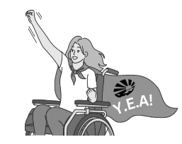
WHO: Youth with disabilities, ages 16 – 21 (must still be in school). Participants should be motivated to be involved in activities and interested in learning and sharing.
WHEN: July 8 – August 1, Monday through Thursday, 1:00pm – 5:00pm daily.
WHERE: Endependence Center, with a community outing on Tuesdays.
TRANSPORTATION: Participants will arrange their own transportation. Paratransit and bus tickets are provided.
June 2024
Endependence Center, Inc. Events
Held at ECI, 6300 E. Virginia Beach Blvd, Norfolk

5th Independent Living Skills Training *DATE CHANGE* 2:00pm – 3:30pm
WED The City of Norfolk is beginning the process to complete a self-evaluation of the City’s compliance with the ADA. During the June ILS Training, we will discuss what a self-evaluation includes and how you can provide input into the City on access to City programs.

12th Consumer Advisory Committee 2:00pm - 3:30pm
WED This month's agenda is to discuss recruiting new members, and current members' terms.

15th Youth Independent Living Skills Training 1:30pm – 3:00pm
SAT How to Meet Deadlines and How to Make a Schedule

25TH Independent Living Skills Training on Podcasts 3:00pm – 4:30pm
TUE This month, we'll learn to edit and listen to the first episode, and begin to plan the next.

26th Advocacy Group 2:00pm – 3:30pm
WED Review of Department of Justice ADA Settlement Agreement with the City of Virginia Beach.

Community Events & News
Transportation tickets are NOT provided to attend community events.

7th Silent Dinner 5:30pm – 8:00pm
FRI Lynnhaven Mall (701 Lynnhaven Parkway, Virginia Beach)
Southside Silent Dinner is a silent, social, family-friendly event for the deaf community, CODA (Child of Deaf Adult), ASL beginners and students, and others interested in ASL.

13th Virginia Relay Virtual Town Hall Meetings 10:30am or 6:30pm
THU PRE-REGISTRATION IS REQUIRED. See page 1 for details.

18th Participant-Led Event 12noon – 2:30pm
TUE Carrabba's Italian Grill (739 Lynnhaven Parkway, Virginia Beach)
This event is organized by participants.

20th Commission on Youth and PEATC In-Person Listening Session 6:00pm – 8:00pm
THU PRE-REGISTRATION IS REQUIRED. See page 1 for details.

22nd TOUCH Group 11:00am – 1:00pm
SAT ECI (6300 E. Virginia Beach Blvd., Norfolk)
Join us for our discussion on understanding our disability and how we adjust to day to day barriers. Your feedback is important, so if you have anything to share or discuss on barriers, come and network with us.

27th Commission on Youth and PEATC In-Person Listening Session 6:00pm – 8:00pm
THU ECI (6300 E. Virginia Beach Blvd., Norfolk)
PRE-REGISTRATION IS REQUIRED. See page 1 for details.

SUNDAY | MONDAY | TUESDAY | WEDNESDAY | THURSDAY | FRIDAY | SATURDAY
 |  |  |  |  |  | 1
 |  | *These events are not organized by ECI. Bus and paratransit tickets will not be provided by ECI.
2 | 3 | 4 | 5 | 6 | 7 | 8
 |  |  | ILS Training *DATE CHANGE*  @ ECI  2:00pm - 3:30pm |  | Silent Dinner*  @ Lynnhaven Mall  5:30pm – 8:00pm | ASL Hangout*  @ Afterglow Brewing  6:00pm – 10:00pm
9 | 10 | 11 | 12 | 13 | 14 | 15
 |  |  | Consumer Advisory Committee (CAC)  @ ECI  2:00pm - 3:30pm | Virginia Relay Town Halls*  (see page 1)  Virtual  10:30am OR 6:30pm |  | Youth ILS Training  @ ECI  1:30pm – 3:00pm
16 | 17 | 18 | 19 | 20 | 21 | 22
 |  | Participant-Led Event*  @ Carrabba's Italian Grill  12noon – 2:30pm | ECI CLOSED IN OBSERVANCE  OF JUNETEENTH | Commission on Youth and PEATC Listening Session  Virtual  6:00pm – 8:00pm |  | TOUCH Group*  @ ECI  11:00am – 1:00pm
23  30 | 24 | 25 | 26 | 27 | 28 | 29
 |  | ILS Training: "What's Bugging You?"  @ ECI  3:00pm – 4:30pm | Advocacy Group  @ ECI  2:00pm – 3:30pm | Commission on Youth and PEATC Listening Session  @ ECI  6:00pm – 8:00pm

June 2024

Disability Advocacy & Services

Endependence Center, Inc.
6300 East Virginia Beach Blvd
Norfolk, VA 23502

Phone:
(757) 461-8007 Voice
(757) 461-7527 TDD

E-Mail:

ecinorf@endependence.org

Website:

www.endependence.org

Newsletter alternate format:
contact (757) 351-1598 or ehoapili@endependence.org

Schedule Changes
Check the ECI website: www.endependence.org
or call
(757) 461-8007, option 4

ELECTRONIC SERVICE REQUESTED

Accommodations
To request accommodations
for ECI activities:
(757) 351-1586 voice
(757) 461-7527 TDD
tmanno@endependence.org

Non-Profit Org.
U.S. Postage
PAID
Norfolk, VA
Permit No. 102

Place label here

Social Media
Facebook: Endependence Center, Inc.-Norfolk, Virginia

