ENDEPENDENCE CENTER NEWSLETTER JULY 2024

***Celebrating the ADA and Disability Pride Month***

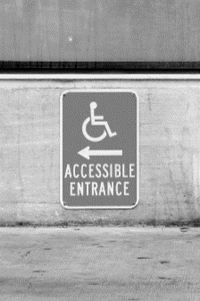

**The Americans with Disabilities Act (ADA) was signed into law on July 26, 1990. Disability Pride Month is celebrated in July to commemorate this landmark legislation.**

*We asked Shernika Holley, ECI's Deaf and Hard of Hearing Outreach Coordinator, to share her experiences with the ADA and what disability pride means to her:*

***What was your experience navigating work, school, and public areas before the ADA? How did it change?*** I remember learning about the ADA in 1990, but I wasn't aware of what it really meant. When I was a senior in high school, my interpreter helped me understand the ADA and the rights I have. She taught me the difference between certified and non-certified interpreters and explained how I can have one provided.

*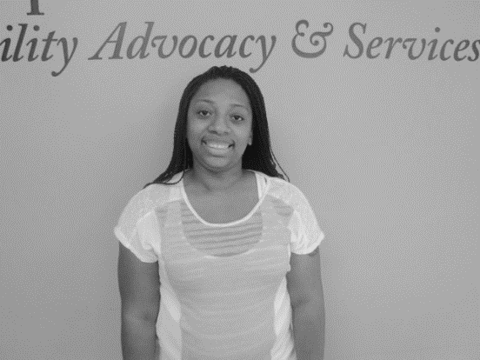****If it weren’t for the ADA, what are some things in your life that would not be possible?*** I would feel shame or embarrassed of my hearing loss if we did not have the ADA. I would not know what was going on. I can read lips, but it is extremely exhausting. In fact, my first semester at ODU wasn't great. I was frustrated with the interpreter I had. Then, I spoke with Educational Accessibility. They really understand reasonable accommodations and approved my request for my preferred interpreter. If I had to take a test or needed more time for homework, I just had to talk to them. Because of the ADA, they gave me what I needed.

***What does "disability pride" mean to you?*** To me, disability pride means I am not ashamed of my disability. I am Deaf, and I am proud of who I am.

*Clockwise from top left: a wall sign directing to an accessible door; Shernika Holley, ECI Staff.*

**Is there a quote that represents disability pride to you?** "Being Deaf does not mean we’re broken." – Sydnee Akers.

# Hampton Roads Transit logo.New Hampton Roads Paratransit Contractor to Hold Information Session at ECI

Hampton Roads Transit will be at ECI on July 9, 2:00pm – 3:30pm with the new paratransit contractor to discuss updates to paratransit services. The meeting is open to the public.

**JULY 2024**

Endependence Center, Inc. Events

Held at ECI, 6300 E. Virginia Beach Blvd, Norfolk

**9th Hampton Roads Paratransit Information Session 2:00pm – 3:30pm**

**TUE** See page 1 for details.

**10th Board of Directors Meeting 1:00pm – 3:00pm**

**WED** ECI Board Meetings are open to the public.

**17th Independent Living Skills Training: Hurricane Preparedness 2:00pm – 3:30pm**

**WED** Learn more about how to be prepared for inclement weather, what zone you live in, evacuation routes, and what you may need to gather before the storm.

**30TH Independent Living Skills Training on Podcasts: What's Bugging You?**

**TUE 3:00pm – 4:30pm**

This month, we'll write our second episode.

**31st Advocacy Group: Celebrating the Anniversary of the ADA 2:00pm – 3:30pm**

**WED** Join us as we celebrate the anniversary of the passage of the Americans with Disabilities Act and discuss the progress made since, and what can still be done.

***NOTE: There will not be a Youth Independent Living Skills Training in July.***

Community Events & News

*Transportation tickets are NOT provided to attend community events.*

**5th Silent Dinner 5:30pm – 8:00pm**

**FRI Lynnhaven Mall (701 Lynnhaven Parkway, Virginia Beach)**

Southside Silent Dinner is a silent, social, family-friendly event for the deaf community, CODA (Child of Deaf Adult), ASL beginners and students, and others interested in ASL.

**13th ASL Hangout 6:00pm – close**

**SAT The Shack (712 Atlantic Ave, Virginia Beach)**

TheASL Hangout goal is to bring deaf, hard of hearing, and hearing people together to socialize and expand the ASL/deaf community.

**16th Participant-Led Event 12noon – 2:30pm**

**TUE Virginia Zoo (3500 Granby Street, Norfolk)**

This event is organized by participants.

# The CAC wants to hear from you!

The Consumer Advisory Committee (CAC) conducts an annual ECI Participant Satisfaction Survey to gather information regarding the quality of services active participants receive from ECI staff. The CAC compiles survey results without interference by ECI staff and presents the findings so we can deliver high quality services and meet participants' needs. **Active participants will receive their survey in the mail. After completing the survey, please use the enclosed return envelope to mail it back. If you prefer, you can also complete the survey online at** [**http://www/endependence.org/feedback**](http://www/endependence.org/feedback)**.**

|  |  |  |  |  |  |  |
| --- | --- | --- | --- | --- | --- | --- |
| **SUNDAY** | **MONDAY** | **TUESDAY** | **WEDNESDAY** | **THURSDAY** | **FRIDAY** | **SATURDAY** |
|  | **1** | **2**  **2** | **3** | **4** | **5** | **6** |
|  |  |  |  | ***Picture of sunglasses with lenses that mimic the American flag. The left lens is stars, and the right lens is stripes.***  ***ECI CLOSED***  ***(FOURTH OF JULY)*** | **Silent Dinner\***  **@ Lynnhaven Mall**  **5:30pm – 8:00pm** |  |
| **7** | **8** | **9** | **10** | **11** | **12** | **13** |
|  | **First Day of Summer YEA! Program** | **HRT Paratransit Info Session**  **@ ECI**  **2:00pm – 3:30pm** | **Board of Directors Meeting**  **@ ECI**  **1:00pm – 3:00pm** |  |  | **ASL Hangout\***  **@ The Shack**  **6:00pm – close** |
| **14** | **15** | **16** | **17** | **18** | **19** | **20** |
|  |  | **Participant-Led Event\***  **@ Virginia Zoo**  **12noon – 2:30pm** | **ILS Training:**  **Hurricane Preparedness**  **@ ECI**  **2:00pm – 3:30pm** |  |  |  |
| **21** | **22** | **23** | **24** | **25** | **26** | **27** |
|  |  |  |  |  | ***Icon of wheelchair user pushing upwards on a ramp.***  ***ADA Anniversary*** |  |
| **28** | **29** | **30** | **31** |  |  |  |
|  |  | **ILS Training: "What's Bugging You?"**  **@ ECI**  **3:00pm – 4:30pm** | **Advocacy Group**  **@ ECI**  **2:00pm – 3:30pm** |  | ***\*These events are not organized by ECI. Bus and paratransit tickets will not be provided by ECI.*** |  |

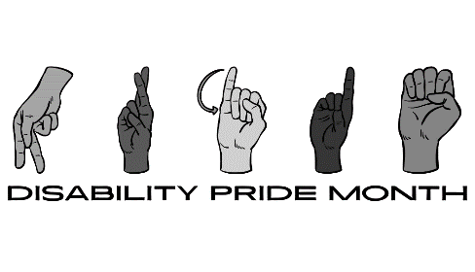July 2024

ECI LogoDisability Advocacy & Services

Endependence Center, Inc.

6300 East Virginia Beach Blvd  
Norfolk, VA 23502

***Phone:***

(757) 461-8007 Voice

(757) 461-7527 TDD

***E-Mail:***

[ecinorf@endependence.org](mailto:ecinorf@endependence.org)

***Website:***

[www.endependence.org](http://www.endependence.org)

***Newsletter alternate format:***

contact (757) 351-1598 or [ehoapili@endependence.org](mailto:ehoapili@endependence.org)

**Schedule Changes**

Check the ECI website: [www.endependence.org](http://www.endependence.org)

or call

(757) 461-8007, option 4

**ELECTRONIC SERVICE REQUESTED**

**Accommodations**

To request accommodations

for ECI activities:

(757) 351-1586 voice

(757) 461-7527 TDD

[tmanno@endependence.org](mailto:tmanno@endependence.org)

**Non-Profit Org.**

**U.S. Postage**

**PAID**

**Norfolk, VA**

**Permit No. 102**

Place label here

**Social Media**

**Facebook:** Endependence Center, Inc.-Norfolk, Virginia