ENDEPENDENCE CENTER NEWSLETTER SEPTEMBER 2024

# Election 2024: Important Dates

Election Day is **Tuesday, November 5**. Other important dates include:

* **September 20: First day of in-person early voting** at registrar's office
* **October 15**: Deadline to **register to vote** (or **update a registration**). Note, anyone who registers after this date can vote through Election Day using a provisional ballot.
* **October 25**: Deadline to **apply for a ballot to be mailed** to you.
* **October 26**: Voter registration offices open on Saturdays for early voting.
* **November 2**: Last-day of in-person early voting.

*Pictured above: a road sign that says "Elections Ahead" with clouds in the background*

# New Law for Curbside Voting

As of July 1, Virginia updated the law surrounding curbside voting. If you are a person with a disability or 65 years of age or older, you can curbside vote.

For more information on voting rights, accessibility for people with disabilities, and links to register or update your voter registration and see who is on your ballot, visit our website.

**Congratulations, Y.E.A. Graduates!**

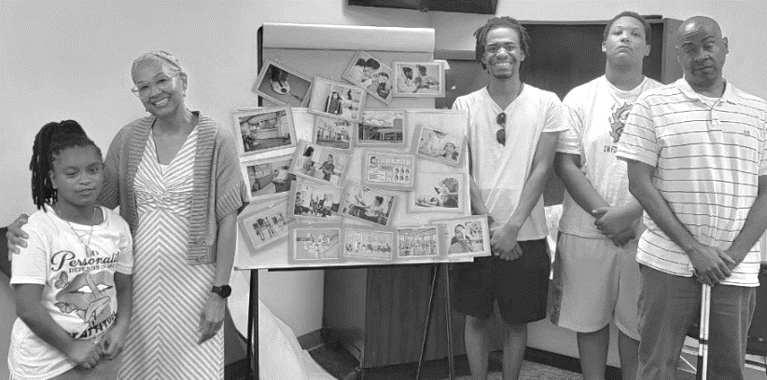Participants of this summer's Youth Endependent Advocates (Y.E.A.) program celebrated their graduation from the program on August 1. Participants learned independent living skills like nutrition, healthcare, budgeting, obtaining housing, resumes, job interviews, and healthy relationships. The group spent time learning about self-advocacy and their rights under the Americans with Disabilities Act, and participated in community outings.

*Pictured above: a group of teenagers and two adults stand next to a board with a collage on an easel.*

ECI extends our gratitude to Y.E.A. participants for their hard work, dedication, and sharing their experiences with us over four weeks.

**SEPTEMBER 2024**

Endependence Center, Inc. Events

Held at ECI, 6300 E. Virginia Beach Blvd, Norfolk

**18th *DATE CHANGE* Board of Directors Meeting 1:00pm – 3:00pm**

**WED** Board of Director meetings are open to the public.

**21st Youth Independent Living Skills Training 1:30pm – 3:00pm**

**SAT** Public Speaking: How to Speak so People Will Listen

**24th Independent Living Skills Training on Podcasts 3:00pm – 4:30pm**

**TUE** This month, we will begin recording our second episode.

**25TH Advocacy Group 2:00pm – 3:30pm**

**WED** The Advocacy Group will be discussing Paratransit this month.

Community Events & News

*Transportation tickets are NOT provided to attend community events.*

**6th Silent Dinner 5:30pm – 8:00pm**

**FRI Lynnhaven Mall (701 Lynnhaven Parkway, Virginia Beach)**

Southside Silent Dinner is a silent, social, family-friendly event for the deaf community, CODA (Child of Deaf Adult), ASL beginners and students, and others interested in ASL.

**14th ASL Hangout 6:00pm – 9:00pm**

**SAT Back Bay's Farmhouse (1805 Kempsville Road, Virginia Beach)**

The ASL Hangout goal is to bring deaf, hard of hearing, and hearing people together to socialize and expand the ASL/deaf community. All users of sign language, any level, are welcome!

**17th Participant-Led Event 12noon – 2:30pm**

**TUE Norfolk Botanical Gardens (6700 Azalea Garden Road, Norfolk)**

This event is organized by participants.

**21st TOUCH Group 11:00am – 1:00pm**

**TUE ECI (6300 E. Virginia Beach Blvd., Norfolk)**

September is our two-year anniversary! Come celebrate with a great discussion on building our confidence in the community and building up your peers.

|  |  |  |  |  |  |  |
| --- | --- | --- | --- | --- | --- | --- |
| **SUNDAY** | **MONDAY** | **TUESDAY** | **WEDNESDAY** | **THURSDAY** | **FRIDAY** | **SATURDAY** |
| 1 | **2** | **3** | **4** | **5** | **6** | **7** |
|  | ***ECI CLOSED IN OBSERVANCE***  ***OF LABOR DAY*** |  |  |  | **Silent Dinner\***  **@ Lynnhaven Mall**  **5:30pm – 8:00pm** |  |
| **8** | **9** | **10** | **11** | **12** | **13** | **14** |
|  |  |  |  |  |  | **ASL Hangout\***  **@ Back Bay's Farmhouse**  **6:00pm -9:00pm** |
| **15** | **16** | **17** | **18** | **19** | **20** | **21** |
|  |  | **Participant-Led Event\***  **@ Norfolk Botanical Gardens**  **12noon – 2:30pm** | **\*DATE CHANGE\***  **Board Meeting**  **@ ECI**  **1:00pm – 3:00pm** |  | ***First Day of***  ***In-Person Early Voting*** | **TOUCH Group\***  **@ ECI**  **11:00am – 1:00pm**  **Youth ILS**  **@ ECI**  **1:30pm – 3:00pm** |
| **22** | **23** | **24** | **25** | **26** | **27** | **28** |
|  |  | **ILS Training: "What's Bugging You?"**  **@ ECI**  **3:00pm – 4:30pm** | **ECI Closed**  **10:00am – 12noon**  **(Staff Meeting)**  **Advocacy Group**  **@ ECI**  **2:00pm – 3:30pm** |  |  |  |
| **29** | **30** |  |  |  |  |  |
|  |  | ***\*These events are not organized by ECI. Bus and paratransit tickets will not be provided by ECI.*** |  |  |  |  |

September 2024

ECI LogoDisability Advocacy & Services

Endependence Center, Inc.

6300 East Virginia Beach Blvd  
Norfolk, VA 23502

***Phone:***

(757) 461-8007 Voice

(757) 461-7527 TDD

***E-Mail:***

[ecinorf@endependence.org](mailto:ecinorf@endependence.org)

***Website:***

[www.endependence.org](http://www.endependence.org)

***Newsletter alternate format:***

contact (757) 351-1598 or [ehoapili@endependence.org](mailto:ehoapili@endependence.org)

**Schedule Changes**

Check the ECI website: [www.endependence.org](http://www.endependence.org)

or call

(757) 461-8007, option 4

**ELECTRONIC SERVICE REQUESTED**

**Accommodations**

To request accommodations

for ECI activities:

(757) 351-1586 voice

(757) 461-7527 TDD

[tmanno@endependence.org](mailto:tmanno@endependence.org)

**Non-Profit Org.**

**U.S. Postage**

**PAID**

**Norfolk, VA**

**Permit No. 102**

Place label here

**Social Media**

**Facebook:** Endependence Center, Inc.-Norfolk, Virginia