ENDEPENDENCE CENTER NEWSLETTER MARCH 2025

**ECI Participants, Staff, and Board Members Attend IL Day in Richmond**

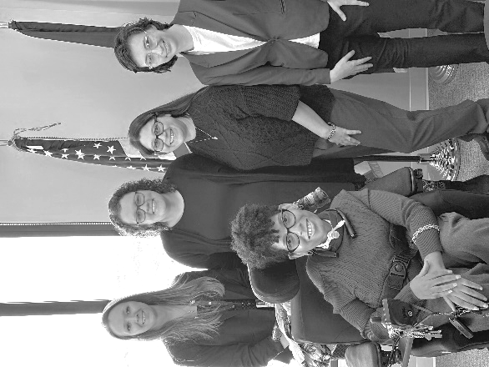On February 4, 25 participants, staff members, board members, and attendants traveled to Richmond for Independent Living (IL) Day, an annual event at the Virginia General Assembly. IL Day brings together Virginia Centers for Independent Living to spend time together and educate our legislators.

The day was filled with meaningful conversations and advocacy efforts, discussing our mission and the critical needs and services that support independent living. After meeting with 20 legislators and their staff, the group returned to ECI inspired and even more motivated to continue advocating for the independent living movement.

*Clockwise from top left: IL Day attendees with Delegate Anna Ferrell Tata's Chief of Staff, IL Day attendees with Senator Aaron Rouse's Chief of Staff, IL Day attendees with Delegate Jackie Glass.*

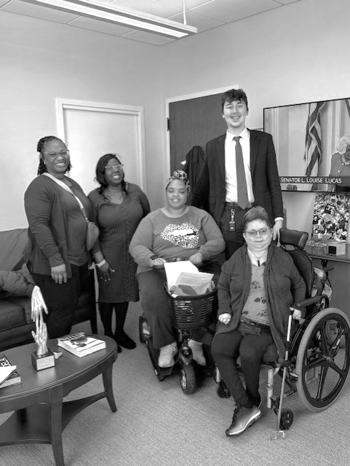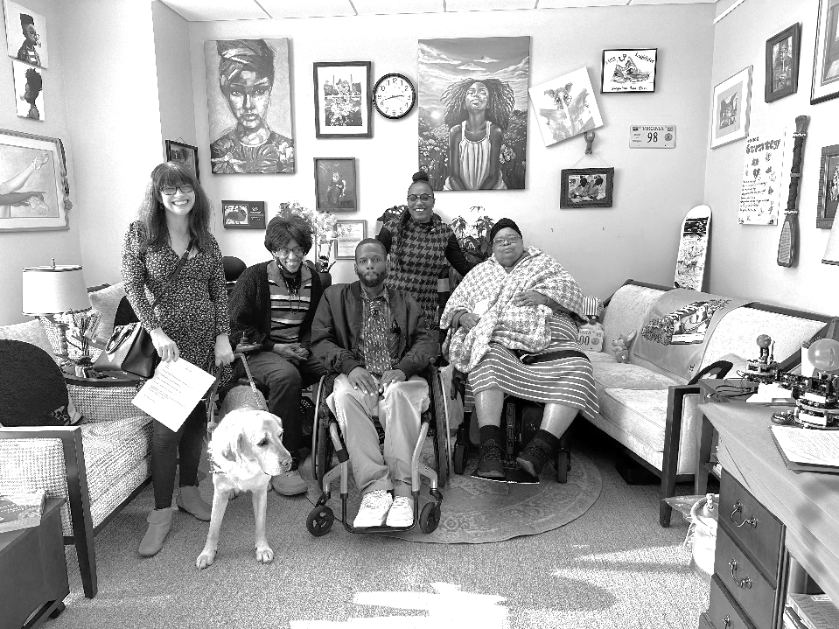

**NRHA 2026 Annual Plan: Public Comment Period Underway**

The Norfolk Redevelopment and Housing Authority (NRHA) Annual Plan for 2026 is available for public review and comment until March 6. The Plan includes information on NRHA’s major goals, strategies and objectives for its assisted-rental properties and Housing Choice Voucher (HCV) program, requirements/mandates, and NRHA’s strategies and objectives for achieving its mission. A link to view the plan can be found on our website, and copies are available at ECI and the NRHA office (555 E. Main Street in Norfolk). Comments can be submitted by calling NRHA’s Public Hearing Comment Hotline at 757-314-1320.

The Board of Commissioners will hold an in-person and virtual public hearing meeting on Thursday, March 13. The meeting is at 555 E. Main Street in the 16th floor boardroom. Members of the public can attend the hearing in person or participate virtually by registering at <https://register.gotowebinar.com/register/8758042668009250912>. The registration link can also be found on the ECI website and Facebook page.

**MARCH 2025**

Endependence Center, Inc. Events

Held at ECI, 6300 E. Virginia Beach Blvd, Norfolk

**19th Independent Living Skills Training: On Demand/Microtransit Services**

**WED 2:00pm - 3:30pm**

This month's ILS training will be presented by Hampton Roads Transit On Demand Transportation Service.

**22nd Youth Independent Living Skills Training 1:30pm – 3:00pm**

**SAT** The monthly Youth Group ILS training will discuss what Healthy Friendships and Relationships look like to you, and how to develop and keep them.

**25th Independent Living Skills Training on Podcasts: What's Bugging You?**

**TUE 3:00pm – 4:30pm**

This month, we will be recording our next episode. *Note, there is no virtual option for this ILS.*

**26th Group Peer Mentoring 2:00pm - 3:30pm**

**WED** The monthly Group Peer Mentoring Discussion is an opportunity for participants to share experiences, provide information, and support one another to accomplish their goals.

Community Events & News

*Transportation tickets are NOT provided to attend community events.*

**7th Silent Dinner 5:30pm – 8:00pm**

**FRI Market Hall Dining Pavillion (1600 Premium Outlets Blvd., Norfolk)**

All are welcome! Come meet the Deaf Community, ASL-English interpreters, ASL students, CODA (Child of Deaf Adult), signers, and others interested in ASL.

**13th Norfolk Redevelopment and Housing Authority**

**THU Board of Commissioners Public Hearing Meeting**

**NRHA 16th Floor Boardroom (555 E. Main Street, Norfolk)**

See page 1.

**15th TOUCH Group 11:00am – 1:00pm**

**SAT ECI (6300 E. Virginia Beach Blvd., Norfolk)**

Come and join us for a conversation on living independently with confidence. Please bring your thoughts and ideas to share with us on living on your own as a person with a Disability.

**22nd ASL Hangout 6:00pm - close**

**SAT Ballyhoos (2865 Lynnhaven Drive, Suite D3, Virginia Beach)**

The ASL Hangout goal is to bring deaf, hard of hearing, and hearing people together to socialize and expand the ASL/deaf community. All users of sign language, any level, are welcome!

|  |  |  |  |  |  |  |
| --- | --- | --- | --- | --- | --- | --- |
| **SUNDAY** | **MONDAY** | **TUESDAY** | **WEDNESDAY** | **THURSDAY** | **FRIDAY** | **SATURDAY** |
|  |  |  |  |  |  | **1** |
|  |  | ***\*This event is not organized by ECI and bus and paratransit tickets will not be provided.*** |  |  |  |  |
| **2** | **3** | **4** | **5** | **6** | **7** | **8** |
|  |  |  |  |  | **Silent Dinner\***  **@ Norfolk Outlets**  **5:30pm – 8:00pm** |  |
| **9** | **10** | **11** | **12** | **13** | **14** | **15** |
|  |  |  |  | **NRHA Board of Commissioners Public Hearing**  **@ NRHA** |  | **TOUCH Group\***  **@ ECI**  **11:00am – 1:00pm** |
| **16** | **17** | **18** | **19** | **20** | **21** | **22** |
|  | ***"Happy St. Patrick's Day" in a playful font, decorated with shamrocks and small sparkles*** |  | **ILS Training**  **@ ECI**  **2:00PM - 3:30PM** |  |  | **Youth Group ILS**  **@ ECI**  **1:30pm – 3:00pm**  **ASL Hangout\***  **@ Ballyhoos**  **6:00pm – close** |
| **23** | **24** | **25** | **26** | **27** | **28** | **29** |
|  |  | **ILS Training on Podcasts**  **@ ECI**  **3:00pm – 4:30pm** | **Group Peer Mentoring**  **@ ECI**  **2:00pm - 3:30pm** |  |  |  |
| **30** | **31** |

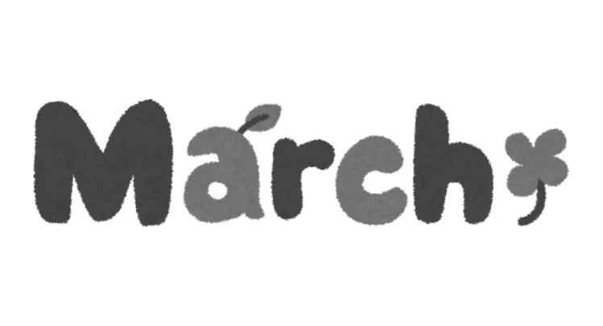MARCH 2025

ECI LogoDisability Advocacy & Services

Endependence Center, Inc.

6300 East Virginia Beach Blvd  
Norfolk, VA 23502

***Phone:***

(757) 461-8007 Voice

(757) 461-7527 TDD

***E-Mail:***

[ecinorf@endependence.org](mailto:ecinorf@endependence.org)

***Website:***

[www.endependence.org](http://www.endependence.org)

***Newsletter alternate format:***

contact (757) 351-1598 or [ehoapili@endependence.org](mailto:ehoapili@endependence.org)

**Schedule Changes**

Check the ECI website: [www.endependence.org](http://www.endependence.org)

**ELECTRONIC SERVICE REQUESTED**

**Accommodations**

To request accommodations

for ECI activities:

(757) 351-1586 voice

(757) 461-7527 TDD

[tmanno@endependence.org](mailto:tmanno@endependence.org)

**Non-Profit Org.**

**U.S. Postage**

**PAID**

**Norfolk, VA**

**Permit No. 102**

Place label here

**Social Media**

**Facebook:** Endependence Center, Inc.-Norfolk, Virginia