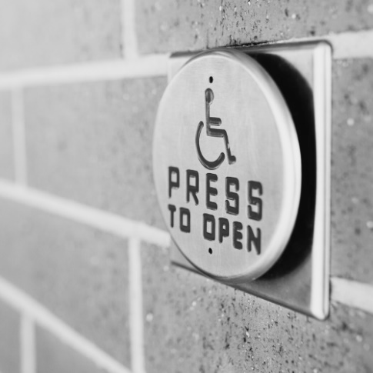**Americans with Disabilities Act (ADA) Training - The Basics**

July 2025 Newsletter

Join us for this basic training in celebration of the 35th anniversary of the ADA.  The  Virginia Association of Centers for Independent Living will facilitate the training. The Mid-Atlantic ADA Center will conduct the training.

**July 16, 2:00-3:30pm, ADA Employment**

**July 30, 2:00-3:30pm, ADA Everything Else**

The training will be virtual using Zoom. Preregistration is required to participate virtually. Preregister at <https://endependence.org/zoom>.

After registering, a link will be sent to you for the event. You only need to preregister once. The same registration will give you access to both the July 16 and July 30 training.

Sign language interpreting and captioning will be provided virtually.

If you would prefer to, you are welcome to join us at the Endependence Center to participate in this training. For more information contact [tmanno@endependence.org](mailto:tmanno@endependence.org), 757-351-1586 voice, 757-461-7527 TDD.

# Logo of What's Bugging You podcastThird Episode of "What's Bugging You?" Now Available

"Navigating Life with Confidence: Tips, Tricks, and Truth": In this episode of *What’s Bugging You?*, people with disabilities get real about the tips, tricks, and tools they use to navigate life their way. From everyday accommodations to unexpected travel hacks, our guests share how they face challenges head-on—living independently and confidently on their own terms.

We talk about how Independent Living Skills (ILS) training supports people in building those tools, how to ask for what you need, and how adjusting to difficult situations can become a personal superpower. You’ll also hear stories about the weirdest things people have assumed about disability—and how our guests respond with grace, humor, and strength. This conversation is full of lived experience, practical advice, and uplifting moments that prove: there’s no one “right” way to live—only the way that works for you.

*What's Bugging You* is available on Spotify, Amazon Music, and more. To find it on your favorite podcast player, visit [endependence.org/whats-bugging-you-episode-three/](https://endependence.org/whats-bugging-you-episode-three/)

**

**July 2025**



## ECI Events

### Unless noted otherwise, events are held at ECI (6300 E. Virginia Beach Blvd., Norfolk)

**9th Board of Directors Meeting 2:00pm - 3:30pm**

**WED** ECI Board of Directors meetings are open to the public.

**16th Americans with Disabilities Act (ADA) Training – The Basics (ADA Employment)**

**WED 2:00pm - 3:30pm**

See page 1 for details.

**28th Americans with Disabilities Act (ADA) Celebration 2:00pm - 3:30pm**

**WED** Please join us to share ADA success stories and what still needs to be done to ensure the promise of the ADA. The Endependence Center will join with other Centers for Independent Living to share stories and celebrate the ADA 35th Anniversary. ECI will develop an ADA time capsule to be opened in 2040 on the 50th anniversary of the ADA. Refreshments will be provided.

**29th Independent Living Skills Training on Podcasts 3:00pm - 4:30pm**

**TUE** This month, we'll come up with some incredible ideas for upcoming episode topics.

**30th Americans with Disabilities Act (ADA) Training – The Basics (ADA Everything Else)**

**WED 2:00pm - 3:30pm**

See page 1 for details.

***There will be no Youth Independent Living Skills training this month.***

## Community Events & News

### Transportation tickets are NOT provided to attend community events.

**7th  PEATC Community Office Hours 10:00am – 1:00pm**

**MON Endependence Center (6300 E. Virginia Beach Blvd., Norfolk)**

This is an opportunity for families to visit Parent Educational Advocacy Training Center (PEATC) staff in-person. For questions, call or text PEATC's Region 2 Family Support Specialist at (757) 271-6613 or visit <https://peatc.org>.

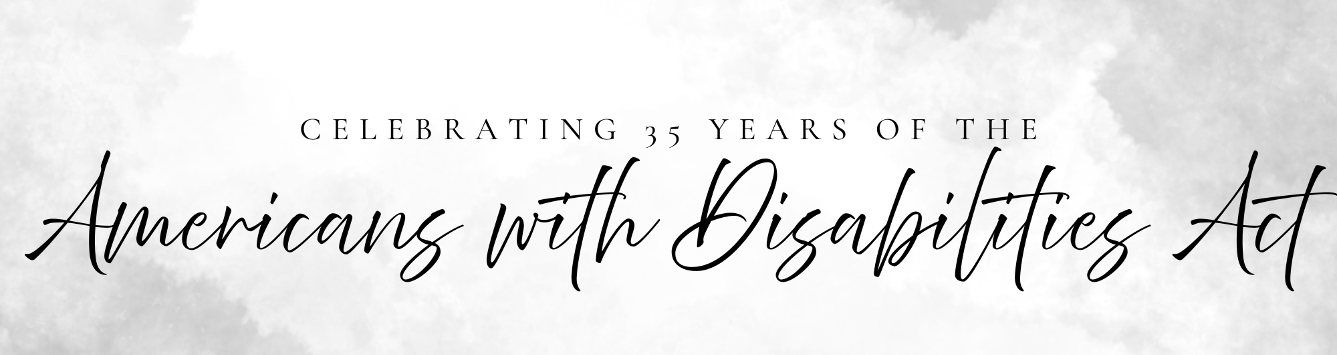

|  |  |  |  |  |  |  |
| --- | --- | --- | --- | --- | --- | --- |
| SUNDAY | MONDAY | TUESDAY | WEDNESDAY | THURSDAY | FRIDAY | SATURDAY |
|  |  | **1** | **2** | **3** | **4** | **5** |
| *Events subject to change. Check the ECI website and Facebook for up-to-date information.* |  |  |  |  | ***Office Closed in Observance of the Fourth of July*** |  |
| **6** | **7** | **8** | **9** | **10** | **11** | **12** |
|  | **PEATC Community Office Hours\***  @ ECI  10:00am – 1:00pm |  | **Board Meeting**  @ ECI  2:00pm - 3:30pm |  |  |  |
| **13** | **14** | **15** | **16** | **17** | **18** | **19** |
|  |  |  | **ADA Training – The Basics**  Virtual  2:00pm - 3:30pm |  |  | **ASL Hangout\***  @ The Shack  6:00pm – 9:00pm |
| **20** | **21** | **22** | **23** | **24** | **25** | **26** |
|  |  |  |  |  |  | Accessibility logo***Anniversary of the ADA*** |
| **27** | **28** | **29** | **30** | **31** |  |  |
|  | **ADA Celebration**  @ ECI  2:00pm - 3:30pm | **ILS Training on Podcasts**  @ ECI  3:00pm – 4:30pm | **ADA Training – The Basics**  Virtual  2:00pm - 3:30pm |  | ***\*This event is not organized by ECI; bus and Paratransit tickets will not be provided.*** |  |

# JULY 2025

***There will not be a Silent Dinner in July.***

***The TOUCH Group will not meet in July.***



Disability Advocacy & Services

**Endependence Center, Inc.**

6300 East Virginia Beach Blvd

Norfolk, VA 23502

**Phone**:

(757) 461-8007 Voice

(757) 461-7527 TDD

**E-Mail**:

[ecinorf@endependence.org](mailto:ecinorf@endependence.org)

**Website**:

[endependence.org](http://www.endependence.org/)

**Accommodations**

To request accommodations

for ECI activities:

(757) 351-1586 voice

(757) 461-7527 TDD

[tmanno@endependence.org](mailto:tmanno@endependence.org)

To request an alternate

format of our newsletter:

(757) 351-1598 voice

(757) 461-7527 TDD

[ehoapili@endependence.org](mailto:ehoapili@endependence.org)

**ELECTRONIC SERVICE REQUESTED**

**Facebook**

[](https://www.facebook.com/ECINorfolk)

**@ECINorfolk**

Endependence Center, Inc. Norfolk Virginia

**Non-Profit Org.**

**U.S. Postage**

**PAID**

**Norfolk, VA**

**Permit No. 102**

**Support ECI**

[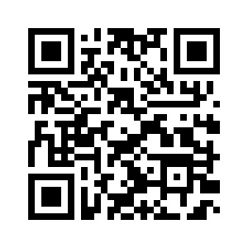](https://endependence.org/donate/)

Scan the QR code above   
to make a tax-deductible donation to ECI via our website, or visit:

[endependence.org/donate](https://endependence.org/donate)