# Federal Benefits Moving to Electronic Payments



October 2025 Newsletter

Effective September 30, federal benefit payments will primary be issued electronically, as *Executive Order 14247, Modernizing Payments To and From America’s Bank Account*, phases out paper checks. If you currently receive federal benefits by paper check, you should switch to an electronic payment option before the deadline. Beneficiaries who request an exemption from the electronic payment requirement must file a waiver with the U.S. Treasury by calling 1-800-967-5042. Per the Social Security Administration, there are two ways to receive federal benefits payments electronically: Direct Deposit to a checking or savings account or a Direct Express® Card, a safe and convenient prepaid debit card option for those without a bank account. Read the press release and find links for changing your payment options on our website at <https://endependence.org>.

# Election Day is Tuesday, November 4

Virginians will elect a Governor, Lieutenant Governor, the Attorney General, the House of Delegates, and each city's constitutional officers: Commonwealth's Attorney, Sheriff, Treasurer, and Commissioner of Revenue. The early voting period is Friday, September 19 to Saturday, November 1. Registrar offices and satellite voting locations will be open on Saturday, October 25 and Saturday, November 1. Friday, October 24 is the deadline to register to vote or update your voter registration. In Virginia, voters can register and vote in-person after October 24 using a provisional ballot. The deadline to apply for a ballot to be mailed to you is 5:00pm on Friday, October 24. **ECI has added a page to our website with a countdown to Election Day, links, important dates, and information on accessible votin**g: <https://endependence.org/election>.

# National Disability Employment Awareness Month

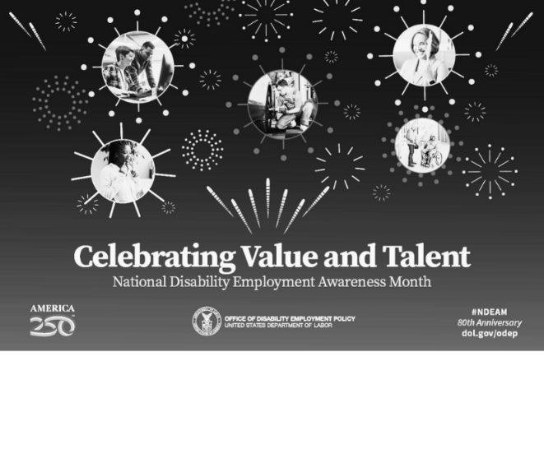This month, we celebrate the 80th anniversary of National Disability Employment Awareness Month (NDEAM), an annual recognition of the positive impact of people with disabilities in the American workforce. NDEAM 2025 will recognize the value and talent American workers with disabilities add to our workplaces and economy and highlight their achievements both past and present.

This yearly event began in 1945 as a weeklong national observance and in 1988, Congress designated the commemoration as NDEAM, which then evolved to acknowledge the importance of increasing opportunities for people with disabilities, including those with mental health conditions and other non-obvious disabilities, in the workforce.

Find out more at <https://dol.gov/odep>.

**

**October 2025**

ECI Events

### Unless noted otherwise, events are held at ECI (6300 E. Virginia Beach Blvd., Norfolk)

**1st Consumer Advisory Committee (CAC) Meeting 2:00pm - 3:30pm**

**WED** New members of the Consumer Advisory Committee will discuss their role. A new version of the Consumer Satisfaction Survey will be drafted. The meeting is open to all participants.

**15th Independent Living Skills Training 2:00pm - 3:30pm**

**WED** Join us as we celebrate the 80th Anniversary of National Disability Employment Awareness Month. Learn about employment support and opportunities that can lead you to successful employment.

**25th Youth Independent Living Skills Training 1:30pm – 3:00pm**

**SAT** We will celebrate the arrival of fall with activities! Costumes are not required, but encouraged. Costumes can be funny or spooky, but should not be excessively scary, noisy, obscene, or revealing. There is no cost to attend. Please RSVP to Amy Ouellette by calling 757-351-1597 or emailing [aouellette@endependence.org](mailto:aouellette@endependence.org) by no later than 5:00pm on Wednesday, October 22.

**28th Independent Living Skills Training on Podcasts 3:00pm - 4:30pm**

**TUE** Recording Session! We'll record both questions and responses.

**29th Group Peer Mentoring 2:00pm - 3:30pm**

**WED** Share experiences, provide information, and support other participants.

**30th Staff & Participant Halloween Celebration 2:00pm - 3:30pm**

**THU** ECI will celebrate Halloween with a Staff & Participant Party! Join us for games, snacks, and a costume contest on Thursday, October 30, 2:00pm – 3:30pm. Costumes are not required, but encouraged. Costumes can be funny or spooky, but should not be excessively scary, noisy, obscene, or revealing. There is no cost to attend. Please RSVP to Katherine Keesler by calling 757-351-1569 or emailing [kkeesler@endependence.org](mailto:kkeesler@endependence.org).

## Community Events & News

### Transportation tickets are NOT provided to attend community events.

**6th  PEATC Community Office Hours 9:30am – 11:30am**

**MON Endependence Center (6300 E. Virginia Beach Blvd., Norfolk)**

This is an opportunity for families to visit Parent Educational Advocacy Training Center (PEATC) staff in-person. For questions, call or text PEATC's Region 2 Family Support Specialist at (757) 271-6613 or visit <https://peatc.org>.

**18th TOUCH Group 11:00am – 1:00pm**

**SAT Endependence Center (6300 E. Virginia Beach Blvd., Norfolk)**

Join us in a conversation on how to navigate gaining employment. Come and tell your story and hear others' on how people with disabilities navigate gaining employment. For questions, contact Montrell Rodgers at 757-238-1293 or [VATOUCH.22@gmail.com](mailto:VATOUCH.22@gmail.com).

# OCTOBER 2025

|  |  |  |  |  |  |  |
| --- | --- | --- | --- | --- | --- | --- |
| SUNDAY | MONDAY | TUESDAY | WEDNESDAY | THURSDAY | FRIDAY | SATURDAY |
|  | *Events subject to change. Check the ECI website and Facebook for up-to-date information.*  ***\*This event is not organized by ECI; bus and Paratransit tickets will not be provided.*** |  | **1** | **2** | **3** | **4** |
|  |  |  | **CAC Meeting**  @ ECI  2:00pm - 3:30pm |  | **Silent Dinner\***  @ Lynnhaven Mall  5:30pm – 8:00pm | **ASL Hangout\***  @ Back Bay's Farmhouse  6:00pm – 9:00pm |
| **5** | **6** | **7** | **8** | **9** | **10** | **11** |
|  | **PEATC Community Office Hours\***  @ ECI  10:00am – 1:00pm |  |  |  |  |  |
| **12** | **13** | **14** | **15** | **16** | **17** | **18** |
|  | ***ECI Closed in Observance of Columbus Day*** |  | **ILS Training:**  **NDEAM Celebration**  @ ECI  2:00pm - 3:30pm |  |  | **TOUCH Group\***  @ ECI  11:00am – 3:30pm |
| **19** | **20** | **21** | **22** | **23** | **24** | **25** |
|  |  |  |  |  | ***Voter Registration Deadline\*\****  ***Deadline to Apply for Mail-In Ballot*** | **Youth ILS: Fall Celebration**  @ ECI  1:30pm – 3:00pm  ***Saturday Early Voting*** |
| **26** | **27** | **28** | **29** | **30** | **31** |  |
|  |  | **ILS Training on Podcasts**  @ ECI  3:00pm – 4:30pm | **Group Peer Mentoring**  @ ECI  2:00pm - 3:30pm | **Staff & Participant Halloween Party**  @ ECI  2:00pm - 3:30pm | Cartoon writing of the phrase "Trick or Treat" |  |

***\*\* In Virginia, voters who register after October 24 can vote through Election Day using a provisional ballot.***



Disability Advocacy & Services

**Endependence Center, Inc.**

6300 East Virginia Beach Blvd

Norfolk, VA 23502

**Phone**:

(757) 461-8007 Voice

(757) 461-7527 TDD

**E-Mail**:

[ecinorf@endependence.org](mailto:ecinorf@endependence.org)

**Website**:

[endependence.org](http://www.endependence.org/)

**Accommodations**

To request accommodations

for ECI activities:

(757) 351-1586 voice

(757) 461-7527 TDD

[tmanno@endependence.org](mailto:tmanno@endependence.org)

To request an alternate

format of our newsletter:

(757) 351-1598 voice

(757) 461-7527 TDD

[ehoapili@endependence.org](mailto:ehoapili@endependence.org)

**ELECTRONIC SERVICE REQUESTED**

**Facebook**

[](https://www.facebook.com/ECINorfolk)

**@ECINorfolk**

Endependence Center, Inc. Norfolk Virginia

**Non-Profit Org.**

**U.S. Postage**

**PAID**

**Norfolk, VA**

**Permit No. 102**

**Support ECI**

[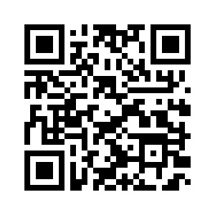](https://endependence.org/donate/)

Scan the QR code above   
to make a tax-deductible donation to ECI via our website, or visit:

[endependence.org/donate](https://endependence.org/donate)