Watch: What is a my Social Security account?
From the Social Security Administration: "We are pleased to share a short video introducing the benefits of creating a personal my Social Security account. This resource provides tools to access important Social Security information and services quickly, securely, and conveniently online.

A my Social Security account is free and secure and allows users to:
- View their earnings history and future benefit estimates
- Apply for retirement or disability benefits online
- Request a replacement Social Security card (in most states)
- Access and print a benefit verification letter
- Manage direct deposit, update address, and more!"
Links to the video can be found on the ECI Facebook page and website.


Your Voice Matters!
November 2025 Newsletter
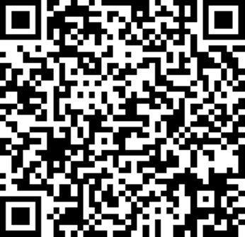
Are you a young person with a disability age 14 – 22, or a parent/caregiver of a child with a disability in this age group? We want to hear from you! Take our short survey about self-advocacy skills and help us create opportunities that make a difference!
You can find the survey at https://www.surveymonkey.com/r/SCNKKTS or by scanning the QR code on the left.

Register Now! 2025 Disability Rights & Resources Summit by dLCV
The disAbility Law Center of Virginia (dLCV) will hold its 2025 Disability Rights and Resources Summit on Thursday, November 13 at 12noon until 5:00pm, virtually. The event is free and open to the public, and is a statewide gathering for people with disabilities, families, advocates, and service providers.
This year's theme is Here. Proud. Empowered. Space is limited and registration is required. To register or for questions, visit the dLCV website at https://dlcv.org or call 804-225-2042.



NOVEMBER 2025

ECI Events

Unless noted otherwise, events are held at ECI (6300 E. Virginia Beach Blvd., Norfolk)
12th Board of Directors Meeting 1:00pm - 3:00pm
WED ECI Board of Directors meetings are open to the public.

13th Technology Assistance Program: Training 12noon – 2:00pm
THU Join us for a presentation about the Virginia Department for the Deaf and Hard of Hearing's Technology Assistance Program, available equipment for participants who are Deaf, Hard of Hearing, DeafBlind, or speech-disabled, and how to apply.

19th Group Peer Mentoring 2:00pm - 3:30pm
WED The monthly Group Peer Mentoring Discussion is an opportunity for participants to share experiences, provide information, and support one another to accomplish their goals.

Community Events & News

Transportation tickets are NOT provided to attend community events.
15th TOUCH Group 11:00am – 1:00pm
SAT Endependence Center (6300 E. Virginia Beach Blvd., Norfolk)
Understanding how your disability affects your daily living and knowing what you can do to make your life easier to become more independent is important. Come and join us and share your great ideas on how you live and maintain your daily life as a person with a disability. For questions, contact Montrell Rodgers at 757-238-1293 or VATOUCH.22@gmail.com.


2025 ECI Participant Holiday Party: RSVP Now
The 2025 Participant Holiday Party will be December 10, 12noon – 3:00pm, at the Philippine Cultural Center, (4857 Baxter Road, Virginia Beach). The party is open to participants only. The cost is $5.00 per person and payable at the door by cash, check, or debit or credit card. Participants may register one guest for $5.00.
REGISTRATION IS REQUIRED. Contact your Independent Living Coordinator to register by Thursday, December 4.
You are encouraged to be responsible for your own transportation to and from the party.

SUNDAY | MONDAY | TUESDAY | WEDNESDAY | THURSDAY | FRIDAY | SATURDAY
 |  |  |  |  |  | 1
Independent Living Skills Training (including youth) will not be held in November.
Events subject to change. Check the ECI website and Facebook for up-to-date information.
*This event is not organized by ECI; bus and Paratransit tickets will not be provided.
2 | 3 | 4 | 5 | 6 | 7 | 8
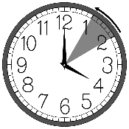  Daylight Saving  Time Ends |  |  |  |  | Silent Dinner*  @ The Burger Bar  5:30pm – 8:00pm | ASL Hangout*  @ The Vanguard Brewpub  6:00pm – 9:00pm
9 | 10 | 11 | 12 | 13 | 14 | 15
 |  | ECI Closed in Observance of Veteran's Day | Board of Directors Meeting  @ ECI  1:00pm – 3:00pm | TAP Training  @ ECI  12noon – 2:00pm |  | TOUCH Group*  @ ECI  11:00am – 1:00pm
16 | 17 | 18 | 19 | 20 | 21 | 22
Group Peer Mentoring
@ ECI
2:00pm - 3:30pm
23 | 24 | 25 | 26 | 27 | 28 | 29
 |  |  | ECI Closed in Observance of Thanksgiving Holiday
30

NOVEMBER 2025


Disability Advocacy & Services

Endependence Center, Inc.
6300 East Virginia Beach Blvd
Norfolk, VA 23502

Phone:
(757) 461-8007 Voice
(757) 461-7527 TDD

E-Mail:
ecinorf@endependence.org

Website:
endependence.org

Accommodations

To request accommodations
for ECI activities:
(757) 351-1586 voice
(757) 461-7527 TDD
tmanno@endependence.org

To request an alternate
format of our newsletter:
(757) 351-1598 voice
(757) 461-7527 TDD
ehoapili@endependence.org

ELECTRONIC SERVICE REQUESTED

Facebook

@ECINorfolk
Endependence Center, Inc. Norfolk Virginia

Non-Profit Org.
U.S. Postage
PAID
Norfolk, VA
Permit No. 102

Support ECI
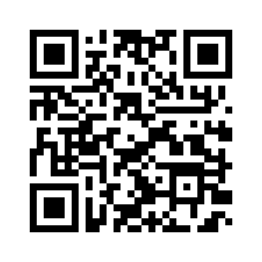
Scan the QR code above
to make a tax-deductible donation to ECI via our website, or visit:
endependence.org/donate

