Participant Holiday Party: RSVP by December 4
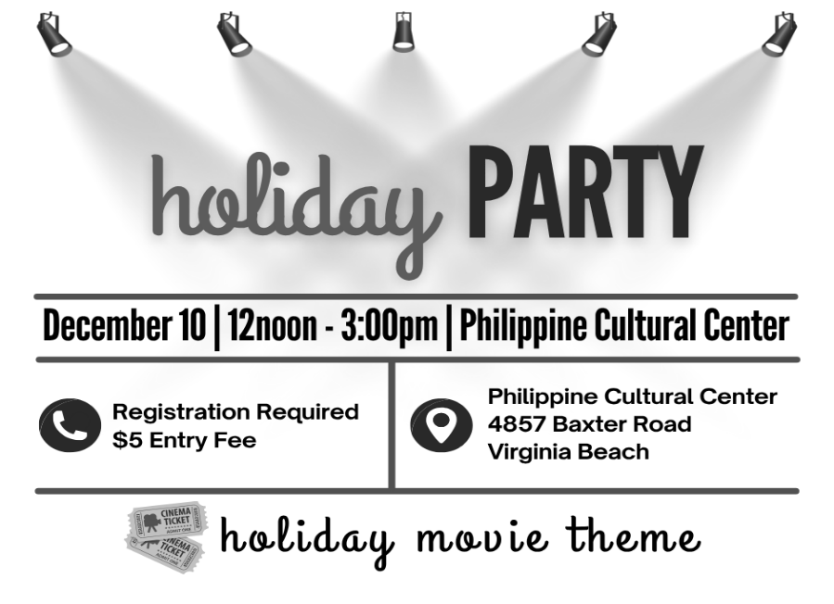
The 2025 Participant Holiday Party will be December 10, 12noon – 3:00pm, at the Philippine Cultural Center, (4857 Baxter Road, Virginia Beach). The party is open to participants only. The cost is $5.00 per person and payable at the door by cash, check, or debit or credit card. Participants may register one guest for $5.00.
REGISTRATION IS REQUIRED. Contact your Independent Living Coordinator to register by Thursday, December 4.
You are encouraged to be responsible for your own transportation to and from the party.

Improving Accessibility in the City of Norfolk: Input Session: December 3, 2:00pm – 3:30pm
The meeting will gather your ideas of how to improve accessibility – what needs to be addressed, what are the priorities, and your suggestions for how to make needed improvements. Adrienne Gardner, Senior Project Manager for Access and Opportunity with the City of Norfolk will facilitate the meeting.
People with disabilities and advocates from other cities are welcome to join the meeting to provide input on your travel, work and use of local government programs and facilities in Norfolk.
To request accommodations for this meeting, contact 757-351-1586, tmanno@endependence.org

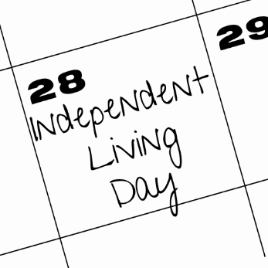
Save the Date: 2026 Independent Living Day
Independent Living Day will be Wednesday, January 28. Independent Living Day is an annual event for people with disabilities to travel to Richmond and join with other advocates to educate legislators about issues important to people with disabilities. If you are interested in participating, speak with your IL Coordinator
December 2025 Newsletter

December 2025

ECI Events

Unless noted otherwise, events are held at ECI (6300 E. Virginia Beach Blvd., Norfolk)
3rd Family Information Session for Youth and Family Transition Services *VIRTUAL OPTION*
WED 6:00pm – 7:30pm
Come and learn about services, classes, programs, and resources to support a successful transition from high school to adult life. To attend via Zoom, visit the ECI website to register.

3rd Improving Accessibility in the City of Norfolk Input Session 2:00pm - 3:30pm
WED See page 1 for details.

10th Annual Participant Holiday Party 12noon - 3:00pm
WED Philippine Cultural Center (4857 Baxter Road, Virginia Beach)
See page 1 for details.

Community Events & News

Transportation tickets are NOT provided to attend community events.
5th Silent Dinner 5:30pm – 8:00pm
FRI Market Hall Dining Pavillion (Norfolk Premium Outlets, 1600 Premium Outlets Blvd., Norfolk)
All are welcome! Come meet the Deaf Community, ASL-English interpreters, ASL students, CODA (Child of Deaf Adult), signers, and others interested in ASL.

10th PEATC Virtual Training – Turning 18: What Individuals with Disabilities Need to Consider
WED 1:00pm *VIRTUAL*
Turning 18 is a big milestone for all young people – and for individuals with disabilities, it comes with important legal, educational, and support considerations. Join Kendra Wormley from the Parent Educational Advocacy Training Center (PEATC) for an informative session on what families need to know as their child transitions into adulthood.
REGISTRATION IS REQUIRED. A minimum of 10 parents must be registered for this training to be held. Recording is not permitted. To register, visit the ECI website.

13th ASL Hang-Out 6:00pm – 9:00pm
FRI Froggies (3656 Shore Drive, Virginia Beach)
All are welcome! Come meet the Deaf Community, ASL-English interpreters, ASL students, CODA (Child of Deaf Adult), signers, and others interested in ASL.

SUNDAY | MONDAY | TUESDAY | WEDNESDAY | THURSDAY | FRIDAY | SATURDAY
 | 1 | 2 | 3 | 4 | 5 | 6
 |  |  | Family Info Session  @ ECI  6:00pm – 7:30pm  Norfolk Input Session  @ ECI  2:00pm - 3:30pm |  | Silent Dinner*  @ Market Hall Dining Pavillion  5:30pm – 8:00pm
7 | 8 | 9 | 10 | 11 | 12 | 13
 |  |  | ECI Office Closed |  |  | ASL Hangout*  @ Froggies  6:00pm – 9:00pm
 |  |  | Participant Holiday Party  @ PCC  12noon – 3:00pm  PEATC Virtual Training 1:00pm |  |  | ASL Hangout*  @ Froggies  6:00pm – 9:00pm
14 | 15 | 16 | 17 | 18 | 19 | 20
 |  |  |  | ECI Office Closed for Staff Event
21 | 22 | 23 | 24 | 25 | 26 | 27
 |  |  | ECI Office Closed in Observance of Holiday | ECI Office Closed in Observance of Holiday | ECI Office Closed in Observance of Holiday
28 | 29 | 30 | 31
Events subject to change. Check the ECI website and Facebook for up-to-date information.
*This event is not organized by ECI; bus and Paratransit tickets will not be provided.


Disability Advocacy & Services

Endependence Center, Inc.
6300 East Virginia Beach Blvd
Norfolk, VA 23502

Phone:
(757) 461-8007 Voice
(757) 461-7527 TDD

E-Mail:
ecinorf@endependence.org

Website:
endependence.org

Accommodations

To request accommodations
for ECI activities:
(757) 351-1586 voice
(757) 461-7527 TDD
tmanno@endependence.org

To request an alternate
format of our newsletter:
(757) 351-1598 voice
(757) 461-7527 TDD
ehoapili@endependence.org

ELECTRONIC SERVICE REQUESTED

Facebook

@ECINorfolk
Endependence Center, Inc. Norfolk Virginia

Non-Profit Org.
U.S. Postage
PAID
Norfolk, VA
Permit No. 102

Support ECI

Scan the QR code above
to make a tax-deductible donation to ECI via our website, or visit:
endependence.org/donate

