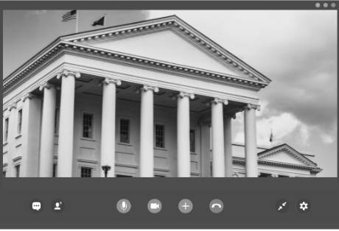
2026 Independent Living Day Goes Virtual
This year's Independent Living Day at the Virginia General Assembly moved to a virtual format after inclement weather impacted travel conditions across the Commonwealth. On January 28, ECI participants, board members, and staff joined other advocates with the Virginia Association of Centers for Independent Living (VACIL) to meet with legislators to discuss independent living and share our community's perspective on VACIL's legislative priorities: establishing a new Center for Independent Living in unserved counties in the Culpepper region, protecting funding, increasing Medicaid personal care rates, addressing the need for palliative care, opposing assisted suicide, addressing issues impacting housing affordability, expanding access to Medicaid Works, and requiring option captioning of movies in theaters.
MARCH 2026 NEWSLETTER

Paralympic Winter Games: March 6 – 15
The Milano Cortina Paralympic Winter Games will hold their Opening Ceremony on March 6th, starting nine days of competition. The 2026 games mark the 50th anniversary of the first Paralympics Winter Games, first held in 1976. That year, 198 athletes from 16 countries traveled to Sweden to compete in two sports. This year, 665 athletes from 50 countries are expected to compete across six sports: para alpine skiing, para biathlon, para cross-country skiing, para ice hockey, para snowboard, and wheelchair curling. For more information, visit https://www.paralympic.org/paralympic-games.

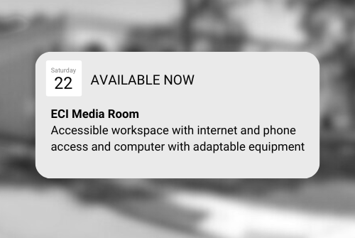
ECI Media Room
ECI's Media Room is an accessible workspace with internet and phone access and a computer with adaptive equipment. It can be used for up to two hours, Monday – Friday, 9:30am to 4:00pm. Availability is not guaranteed and reservations are encouraged. For more information or to reserve the space, contact your IL Coordinator.

ECI Events
MARCH 2026

Unless noted otherwise, events are held at ECI (6300 E. Virginia Beach Blvd., Norfolk)
11th ECI Board of Directors Meeting 1:00pm - 3:00pm
WED ECI Board of Directors meetings are open to the public.
11th Connect & Grow 2:00pm - 3:30pm
WED Connect & Grow is a fun, welcoming space where ECI participants come together to make connections, share laughs, learn, and grow together as part of our independent living community.
18th Federal Benefits Training *VIRTUAL OPTION* 1:00pm - 3:00pm
WED Join us for an informative training on federal benefit programs, including SSI, SSDI, Medicaid, Medicare, and SNAP. Learn about recent updates and policy changes. This training will be held in-person and via Zoom. To register, visit https://endependence.org/zoom.
25th Group Peer Mentoring 2:00pm - 3:30pm
WED The monthly Group Peer Mentoring Discussion is an opportunity for participants to share experiences, provide information, and support one another to accomplish their goals.
26th Advocacy Coalition 2:00pm - 3:30pm
THU As the General Assembly session concludes, ECI is convening organizations from across the Tidewater region that advocate with and alongside people with disabilities for a collaborative debrief and discussion. Together, we will discuss what has passed, what was carried over, and share our perspectives on ongoing advocacy priorities impacting people with disabilities and independent living in our communities.
28th Youth Independent Living Skills Training: Cooking Class: Beyond Frozen Dinners
SAT 1:30pm – 3:00pm
This month, we'll be having a cooking class. We will be learning how to prepare food using the microwave. Please RSVP to Amy Ouellette at (757) 351-1597 or aouellette@endependence.org by no later than 5pm on Wednesday, March 25th.
31st Independent Living Skills Training on Podcasts 3:00pm - 4:30pm
TUE This month, we'll finish episode 4.

Community & Participant-Led Events

Transportation tickets are NOT provided to attend community events.
17th *GRAND RE-OPENING* Participant-Led Event 12noon – 2:30pm
TUE Applebee's Bar & Grill at Janaf (5750 E Virginia Beach Blvd., Norfolk)
This event is organized by participants.
21st TOUCH Group 11:00am – 1:00pm
SAT Endependence Center (6300 E. Virginia Beach Blvd., Norfolk)
Come and join us to discuss ideas on how we can be better at budgeting our finances. For questions, contact Montrell Rodgers at 757-238-1293 or VATOUCH.22@gmail.com.
27th Women's Group (Participant-Led Group) 3:00pm – 4:00pm
FRI Endependence Center (6300 E. Virginia Beach Blvd., Norfolk)
Topic for March: Wellness & Nutrition
SUNDAY | MONDAY | TUESDAY | WEDNESDAY | THURSDAY | FRIDAY | SATURDAY
1 | 2 | 3 | 4 | 5 | 6 | 7
Silent Dinner*
@ Lynnhaven Mall
5:30pm – 8:00pm
8 | 9 | 10 | 11 | 12 | 13 | 14
 |  | Statewide Tornado Drill at 9:45am | Board Meeting  @ ECI  1:00pm – 3:00pm  Connect & Grow  @ ECI  2:00pm - 3:30pm
15 | 16 | 17 | 18 | 19 | 20 | 21
 |  | Participant-Led Event (Grand  Re-Opening)*  @ Applebee's at Janaf  12noon – 2:30pm | Federal Benefits Training  @ ECI or via Zoom  1:00pm – 3:00pm |  |  | TOUCH Group*  @ ECI  11:00am – 1:00pm  ASL Hangout*  @ Voodoo Brewing  6:00pm – 9:00pm
22 | 23 | 24 | 25 | 26 | 27 | 28
 |  |  | Group Peer Mentoring  @ ECI  2:00pm - 3:30pm | Advocacy Coalition  @ ECI  2:00pm - 3:30pm | Women's Group*  @ ECI  3:00pm – 4:30pm | Youth ILS: Beyond Frozen Dinners  @ ECI  1:30pm – 3:00pm
29 | 30 | 31
 |  | ILS Training on Podcasts  @ ECI  3:00pm – 4:30pm | Events subject to change. Check the ECI website and Facebook for up-to-date information.  *This event is not organized by ECI; bus and Paratransit tickets will not be provided.


Disability Advocacy & Services

Endependence Center, Inc.
6300 East Virginia Beach Blvd
Norfolk, VA 23502

Phone:
(757) 461-8007 Voice
(757) 461-7527 TDD

E-Mail:
ecinorf@endependence.org

Website:
endependence.org

Accommodations

To request accommodations
for ECI activities:
(757) 351-1586 voice
(757) 461-7527 TDD
tmanno@endependence.org

To request an alternate
format of our newsletter:
(757) 351-1598 voice
(757) 461-7527 TDD
ehoapili@endependence.org

ELECTRONIC SERVICE REQUESTED

Facebook

@ECINorfolk
Endependence Center, Inc. Norfolk Virginia

Non-Profit Org.
U.S. Postage
PAID
Norfolk, VA
Permit No. 102

Support ECI

Scan the QR code above
to make a tax-deductible donation to ECI via our website, or visit:
endependence.org/donate

