Connect & Grow: Building Connections in a Fun, Welcoming Space
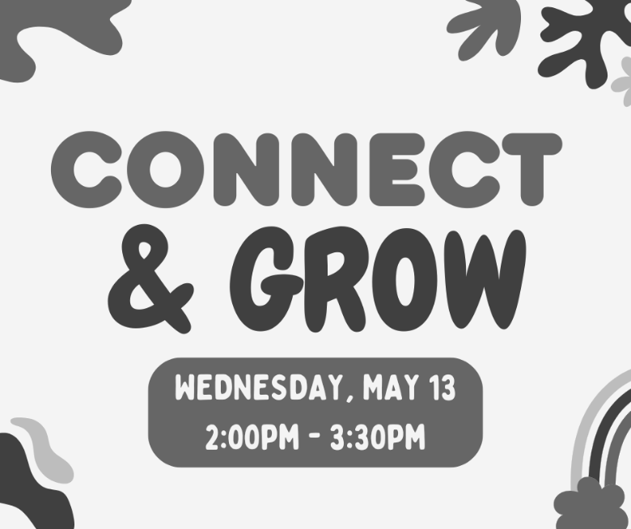
Connect & Grow is a fun, welcoming space created just for ECI participants. It’s a place to unwind, make new connections, share laughs, and enjoy time with peers. Whether you’re playing games, relaxing, or learning something new together, Connect & Grow offers a supportive environment for participants to work on their personal socialization goals and where everyone can feel comfortable being themselves.
This group is all about building community, strengthening independence, and having a great time along the way — and it’s just for you. May's Connect & Grow will be Wednesday, May 13 at 2:00pm - 3:30pm. Please speak with your IL Coordinator to attend.
May 2026 Newsletter

Supported Decision-Making: Free Virtual Training

A free virtual training will be held on Tuesday, May 19, 2:00pm - 3:30pm. Learn how Supported Decision-Making empowers individuals with disabilities to make their own choices with the support they need, while maintaining independence and control over their own lives. This virtual informative session will be led by Dana Traynham, Senior Attorney at the DisAbility Law Center of Virginia (dLCV), and will cover practical strategies, legal considerations, and ways to promote autonomy in everyday decision-making. REGISTRATION IS REQUIRED. A registration link can be found at https://endependence.org/zoom.

Spring is Here: Get Notified for Severe Weather

Did you know you can sign up to receive emergency alerts from the city you live and/or work in? Local cities send text and/or email alerts for weather watches and warnings and other emergencies. You can sign up for these alerts on localities' websites—the links to visit each city or county website can be found on our website, as well as links to find out what flood zone your house or workplace are in. Knowing your flood zone helps residents know what to expect, and if an area needs to evacuate, help you better understand instructions from City officials.
May 2026 Newsletter

ECI Events
MAY 2026

Unless noted otherwise, events are held at ECI (6300 E. Virginia Beach Blvd., Norfolk)
13th Board of Directors Meeting 1:00pm – 3:00pm
WED ECI Board of Directors meetings are open to the public.
13th Connect & Grow 2:00pm - 3:30pm
WED See page one for details.
20th Independent Living Skills Training: Paratransit 2:00pm - 3:30pm
WED We'll discuss rules and regulations for Paratransit services, and how to apply.
26th Independent Living Skills Training on Podcasts 2:00pm - 3:30pm
TUE This month, participants will interview staff.
27th Group Peer Mentoring 2:00pm - 3:30pm
WED The monthly Group Peer Mentoring Discussion is an opportunity for participants to share experiences, provide information, and support one another to accomplish their goals.
28th Advocacy Coalition 2:00pm - 3:30pm
THU Collaborative conversations help us identify shared needs, strengthen partnerships, and advance inclusive communities. This gathering will highlight current issues, allow organizations to learn from one another, and encourage coordinated advocacy.
30th Youth Independent Living Skills Training 1:30pm – 3:00pm
SAT This month, we will be having a conversation and discussion about self-advocacy. This includes what self-advocacy means, ways to speak up for yourself, and ways to make your voice heard.

Community Events

Transportation tickets are NOT provided to attend community events.
2nd TOUCH Group: Bowling Event 12noon – 2:00pm
SAT AMF Norfolk Lanes (2441 E. Little Creek Road, Norfolk)
For questions, contact Montrell Rodgers at 757-238-1293 or VATOUCH.22@gmail.com.
6th Transit Riders Advisory Committee (TRAC) 6:00pm
WED Hampton Roads Transit (3400 Victoria Blvd., Hampton)
TRAC offers guidance to HRT by providing feedback on service operations and customer experience. For more information, contact Henry Ryto at (757) 222‑6000 or hryto@hrtransit.org.
16th TOUCH Group 11:00am – 1:00pm
SAT Endependence Center (6300 E. Virginia Beach Blvd., Norfolk)
Let's get together and discuss how we can continue to motivate and encourage one another, as people with disabilities. For questions, contact Montrell Rodgers at 757-238-1293 or VATOUCH.22@gmail.com.
19th Participant-Led Event 12noon – 2:30pm
TUE Denny's (6360 Newtown Road, Norfolk)
This event is organized by participants.
19th Supported Decision-Making: Free Statewide Virtual Training 2:00pm - 3:30pm
TUE See page one for details. Registration is required.

The Participant-Led Women's Group will not meet in May.

SUNDAY | MONDAY | TUESDAY | WEDNESDAY | THURSDAY | FRIDAY | SATURDAY
Events subject to change. Check the ECI website and Facebook for up-to-date information.  *This event is not organized by ECI; bus and Paratransit tickets will not be provided. |  |  |  |  | 1 | 2
 |  |  |  |  | Silent Dinner*  @ Lynnhaven Mall  5:30pm – 8:00pm | TOUCH Group Bowling Event*  @ AMF Norfolk Lanes  12noon – 2:00pm
3 | 4 | 5 | 6 | 7 | 8 | 9
HRT TRAC Meeting*
@ HRT Hampton Office
6:00pm
10 | 11 | 12 | 13 | 14 | 15 | 16
 |  |  | Board of Directors Meeting  @ ECI  1:00pm – 3:00pm  Connect & Grow  @ ECI  2:00pm - 3:30pm |  |  | ASL Hangout*  @ Chick's Oyster Bar  6:00pm – 9:00pm  TOUCH Group*  @ ECI  11:00am – 1:00pm
17 | 18 | 19 | 20 | 21 | 22 | 23
 |  | Participant-Led Event*  @ Denny's (Norfolk)  12noon – 2:30pm  Supported Decision-Making: Virtual Training  2:00pm - 3:30pm | ILS Training: Paratransit  @ ECI  2:00pm - 3:30pm
24 | 25 | 26 | 27 | 28 | 29 | 30
 | Memorial Day  (ECI Office Closed) | ILS Training on Podcasts  @ ECI  2:00pm - 3:30pm | Group Peer Mentoring  @ ECI  2:00pm - 3:30pm | Advocacy Coalition  @ ECI  2:00pm - 3:30pm |  | Youth ILS  @ ECI  1:30pm – 3:00pm
31


Disability Advocacy & Services

Endependence Center, Inc.
6300 East Virginia Beach Blvd
Norfolk, VA 23502

Phone:
(757) 461-8007 Voice
(757) 461-7527 TDD

E-Mail:
ecinorf@endependence.org

Website:
endependence.org

Accommodations

To request accommodations
for ECI activities:
(757) 351-1586 voice
(757) 461-7527 TDD
tmanno@endependence.org

To request an alternate
format of our newsletter:
(757) 351-1598 voice
(757) 461-7527 TDD
ehoapili@endependence.org

ELECTRONIC SERVICE REQUESTED

Facebook

@ECINorfolk
Endependence Center, Inc. Norfolk Virginia

Non-Profit Org.
U.S. Postage
PAID
Norfolk, VA
Permit No. 102

Support ECI

Scan the QR code above
to make a tax-deductible donation to ECI via our website, or visit:
endependence.org/donate

