July 26: The Americans with Disabilities Act Turns 36
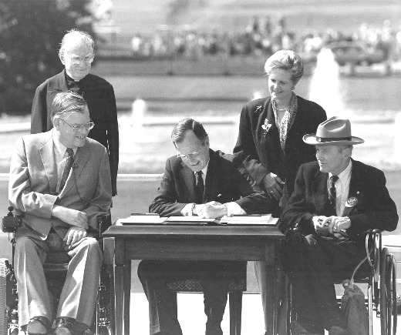
President George H. W. Bush signed the Americans with Disabilities Act (ADA) into law on July 26, 1990.
Pictured left: President George H.W. Bush signing the ADA on the South Lawn of the White House on July 26, 1990. From left to right: Rev. Harold Wilke; Evan Kemp, Chairman of the Equal Employment Opportunity Commission; President Bush; Justin Dart, Chairman of the President’s Committee on Employment of People with Disabilities; Swift Parrino, Chairperson of the National Council on Disability. (White House Photograph Office, Collection GB-WHPO, WHPC-A-P14777(18))

Americans with Disabilities Act Training & Celebration
Learn the ADA, celebrate the impact! Join us Wednesday, July 29, 2:00pm - 3:30pm, to review the basics of the ADA and celebrate how the ADA impacted your life this year.

Rental Discrimination: Share Your Experiences
According to the National Fair Housing Alliance, 54% of fair housing complaints filed in 2024 were on the basis of disability. ECI is distributing a Rental Application Survey for people with disabilities to share their experiences contacting landlords, completing rental applications, and going through the approval process, as well as the applications themselves.

To complete the survey, you can pick one up at the ECI office or ask an ECI staff member to send you one. You can also scan the QR code on the left or visit our website to complete the survey online. Our goal is to find patterns, increase education and awareness for our community, and support fair housing for all.

Turning Points: The Disability Rights Movement Training
Join the Mid-Atlantic ADA Center on Thursday, July 16, 2:00pm – 3:30pm, for a virtual event to revisit some of the pivotal events of the disability rights movement, recognize some of the pioneers who led the way, and acknowledge the power of community that keeps us moving forward on the journey from isolation to inclusion of people with disabilities. Visit https://endependence.org/zoom to find the link to register.
July 2026 Newsletter

ECI Events
July 2026

Unless noted otherwise, events are held at ECI (6300 E. Virginia Beach Blvd., Norfolk)
8th ECI Board of Directors Meeting 1:00pm - 3:00pm
WED ECI Board of Directors meetings are open to the public.
8th Connect & Grow 2:00pm - 3:30pm
WED Connect & Grow is a fun, welcoming space where ECI participants come together to make connections, share laughs, learn, and grow together as part of our independent living community.
28th Independent Living Skills Training on Podcasts 2:00pm - 3:30pm
TUE This month, we'll record more answers from participants and staff for our next episode.
29th Americans with Disabilities Act Training & Celebration 2:00pm - 3:30pm
WED See page one for details.
Due to the ADA Training & Celebration, Group Peer Mentoring will not meet in July.
There will be no Youth ILS in July. We will resume in August with an end of summer ice cream social.

Community Events

Transportation tickets are NOT provided to attend community events.
1st Hampton Roads Transit Riders Advisory Committee (TRAC) 6:00pm
WED HRT Office (509 East 18th Street, Bldg. 4, Norfolk)
The Transit Riders Advisory Committee (TRAC) offers guidance to HRT by providing feedback on service operations and customer experience. For more information, contact Henry Ryto at (757) 222‑6000 or hryto@hrtransit.org.
6th PEATC Community Office Hours 9:00am – 11:00am
MON This is an opportunity for families to visit Parent Educational Advocacy Training Center (PEATC) staff for one-on-one, in-person support. For questions, call PEATC's Region 2 Family Support Specialist at (703) 923-0010 or visit https://peatc.org.
16th Turning Points: The Disability Rights Movement (Virtual Training) 2:00pm - 3:30pm
THU See page one for details.
21st Participant-Led Event 12noon – 2:30pm
TUE Lynnhaven Mall (701 Lynnhaven Parkway, Virginia Beach)
This event is organized by participants.
31st Women's Group 2:00pm – 3:30pm
FRI Endependence Center (6300 E. Virginia Beach Blvd., Norfolk)
This month, we’ll talk about our goals and future plans for living on our own.

En Español: ADA Series from Mid-Atlantic ADA Center
The ADA Disability Rights Series hosted by the Mid-Atlantic ADA Center and the Endependence Center of Northern Virginia (ECNV) continues in July with "Assistive Technology" on Wednesday, July 01 and "Other Things You Need to Know" on Wednesday, July 8. Both sessions are at 6:00pm. This series is presented entirely in Spanish. Visit the ECI website (https://endependence.org/zoom) to find the link to register.

SUNDAY | MONDAY | TUESDAY | WEDNESDAY | THURSDAY | FRIDAY | SATURDAY
 |  | Events subject to change. Check the ECI website and Facebook for up-to-date information.  *This event is not organized by ECI; bus and Paratransit tickets will not be provided. | 1 | 2 | 3 | 4
 |  |  | HRT Transit Riders Committee*  @ TDCHR (Norfolk)  6:00pm  En Español: Assistive Technology*  Virtual | 6:00pm |  | ECI Closed in Observance of the Fourth of July | Fourth of July
5 | 6 | 7 | 8 | 9 | 10 | 11
 | PEATC Community Office Hours*  @ ECI  9:00am – 11:00am |  | Board Meeting  @ ECI | 1:00pm – 3:00pm  Connect & Grow  @ ECI | 2:00pm - 3:30pm  En Español: Other Things You Need to Know*  Virtual | 6:00pm
12 | 13 | 14 | 15 | 16 | 17 | 18
Turning Points: The Disability Rights Movement Training*
Virtual
2:00pm – 3:30pm
19 | 20 | 21 | 22 | 23 | 24 | 25
Participant-Led Event*
@ Lynnhaven Mall
12noon – 2:30pm
26 | 27 | 28 | 29 | 30 | 31
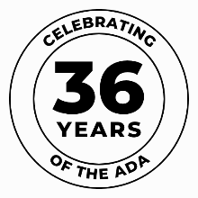 |  | ILS Training on Podcasts  @ ECI  2:00pm - 3:30pm | ADA Training & Celebration  @ ECI  2:00pm - 3:30pm |  | Women's Group*  @ ECI  2:00pm – 3:30pm


Disability Advocacy & Services

Endependence Center, Inc.
6300 East Virginia Beach Blvd
Norfolk, VA 23502

Phone:
(757) 461-8007 Voice
(757) 461-7527 TDD

E-Mail:
ecinorf@endependence.org

Website:
endependence.org

Accommodations

To request accommodations
for ECI activities:
(757) 351-1586 voice
(757) 461-7527 TDD
tmanno@endependence.org

To request an alternate
format of our newsletter:
(757) 351-1598 voice
(757) 461-7527 TDD
ehoapili@endependence.org

ELECTRONIC SERVICE REQUESTED

Facebook

@ECINorfolk
Endependence Center, Inc. Norfolk Virginia

Non-Profit Org.
U.S. Postage
PAID
Norfolk, VA
Permit No. 102

Support ECI
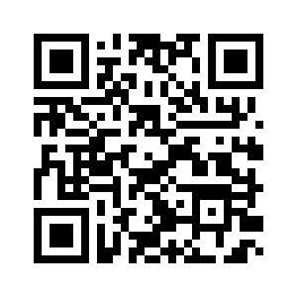
Scan the QR code above
to make a tax-deductible donation to ECI via our website, or visit:
endependence.org/donate

