Help Us Identify Housing Discrimination: Take the ECI Rental Application Survey
October 2026 Newsletter
Endependence Center staff have been working to identify the extent of illegal and unfair incidents and practices that prevent people with disabilities from accessing housing, from the first contact with the landlord to ask about available housing, the rental application itself, or how applications are processed.
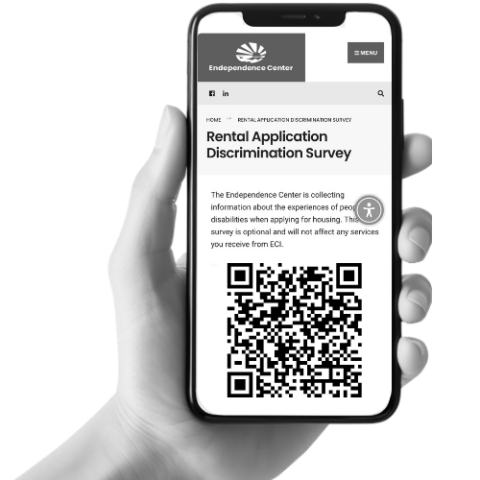
To help us collect data on these types of occurrences, we are distributing a Rental Application Discrimination Survey. According to the National Fair Housing Alliance, 54% of fair housing complaints filed in 2024 were on the basis of disability. Our goal is to identify patterns that can be addressed through fair housing education and awareness to landlords to resolve both intentional and unintentional incidents, and assist participants with filing a complaint.
Scan the QR code on the left or visit the ECI website to complete the survey online. Paper versions are available in the ECI lobby or from staff. For assistance with a discriminating housing issue, please include your contact information on the form.

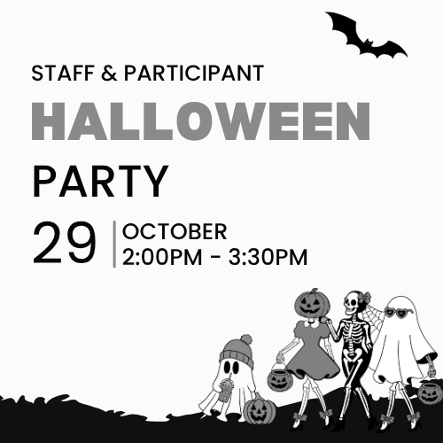
October 29: Staff & Participant Halloween Celebration & Costume Contest
ECI will celebrate Halloween with a Staff & Participant Party! Join us for games, snacks, and a costume contest on Thursday, October 29, 2:00pm – 3:30pm. Costumes are not required but encouraged. Costumes can be funny or spooky, but should not be excessively scary, noisy, obscene, or revealing. There is no cost to attend. Please RSVP to Justin Johnson by calling 757-351-1592 or emailing jjohnson@endependence.org.

ECI Events Unless noted otherwise, events are held at ECI (6300 E. Virginia Beach Blvd., Norfolk
OCTOBER 2026
7th Consumer Advisory Committee (CAC) Meeting 2:00pm - 3:30pm
WED Meeting agenda includes discussion of the new Participant Satisfaction Survey.
14th ECI Annual Meeting 2:00pm – 4:00pm
WED Registration is required.
28th Group Peer Mentoring 2:00pm - 3:30pm
WED The monthly Group Peer Mentoring Discussion is an opportunity for participants to share experiences, provide information, and support one another to accomplish their goals.
29th Staff & Participant Halloween Party 2:00pm - 3:30pm
THU See page one for details.
31st Youth Group: Fall Celebration 1:30pm – 3:00pm
SAT We will be having a fall celebration with activities included! Costumes are not required but encouraged. Costumes can be funny or spooky, but should not be excessively scary, noisy, obscene, or revealing. There is no cost to attend. To RSVP, contact Amy Ouellette at 757-351-1597 or aouellette@endependence.org by no later than 5:00pm on Wednesday, October 28.

Connect & Grow will not meet this month.

Community Events Transportation tickets are NOT provided to attend community events.
5th PEATC Community Office Hours 9:00am – 11:00am
MON The Parent Educational Advocacy Training Center (PEATC) offers free and confidential services to assist in navigating the special education system. For questions, call (703) 923-0010 or visit https://peatc.org.
14th HRT Paratransit Advisory Committee 1:00pm
WED Hampton Roads Transit (509 East 18th Street, Bldg. 4, Norfolk)
Meetings are free and open to the public in person or via Zoom. For more information, call (757) 222-6087 or e-mail paratransitdept@hrtransit.org.
17th TOUCH Group 11:00am – 1:00pm
SAT Endependence Center (6300 E. Virginia Beach Blvd., Norfolk)
Come and join the TOUCH Group for a discussion about making changes and how change affects us. We look forward to your input and your ideas. For questions, contact Montrell Rodgers at 757-238-1293 or VATOUCH.22@gmail.com.
20th Participant-Led Event 12noon – 2:30pm
TUE Pinboy's at the Beach (1577 Laskin Road Suite 100, Virginia Beach)
This event is organized by participants.
30th Participant-Led Women's Group 2:00pm - 3:30pm
FRI Endependence Center (6300 E. Virginia Beach Blvd., Norfolk)
Discussion this month will be centered on mental health.

SUNDAY | MONDAY | TUESDAY | WEDNESDAY | THURSDAY | FRIDAY | SATURDAY
 |  |  |  | 1 | 2 | 3
 | Events subject to change. Check the ECI website and Facebook for up-to-date information.  *This event is not organized by ECI; bus and Paratransit tickets will not be provided. |  |  |  | Silent Dinner*  @ Lynnhaven Mall  5:30pm – 8:00pm | ASL Hangout*  @ Voodoo Brewing Co  6:00pm – 9:00pm  ASL Sip & Sign (Voices Off)*  @ Pinup Coffee at Farmhouse  10:00am – 11:00am
4 | 5 | 6 | 7 | 8 | 9 | 10
 | PEATC Community Office Hours*  @ ECI  9:00am – 11:00am |  | CAC Meeting  @ ECI  2:00pm - 3:30pm
11 | 12 | 13 | 14 | 15 | 16 | 17
 | ECI Closed in Observance of Columbus Day |  | HRT Paratransit Advisory Committee*  @ TDCHR (Norfolk)  1:00pm  ECI Annual Meeting  @ Jordan-Newby Library  2:00pm – 4:00pm |  |  | TOUCH Group*  @ ECI  11:00am – 1:00pm
18 | 19 | 20 | 21 | 22 | 23 | 24
Participant-Led Event*
@ Pinboys (Virginia Beach)
12noon – 2:30pm
25 | 26 | 27 | 28 | 29 | 30 | 31
 |  |  | Group Peer Mentoring  @ ECI  2:00pm - 3:30pm | Staff & Participant Halloween Party  @ ECI  2:00pm - 3:30pm | Participant-Led Women's Group*  @ ECI  2:00pm - 3:30pm | Youth ILS: Fall Celebration  @ ECI  1:30pm – 3:00pm


Disability Advocacy & Services

Endependence Center, Inc.
6300 East Virginia Beach Blvd
Norfolk, VA 23502

Phone:
(757) 461-8007 Voice
(757) 461-7527 TDD

E-Mail:
ecinorf@endependence.org

Website:
endependence.org

Accommodations

To request accommodations
for ECI activities:
(757) 351-1586 voice
(757) 461-7527 TDD
tmanno@endependence.org

To request an alternate
format of our newsletter:
(757) 351-1598 voice
(757) 461-7527 TDD
ehoapili@endependence.org

ELECTRONIC SERVICE REQUESTED

Facebook

@ECINorfolk
Endependence Center, Inc. Norfolk Virginia

Non-Profit Org.
U.S. Postage
PAID
Norfolk, VA
Permit No. 102

Support ECI
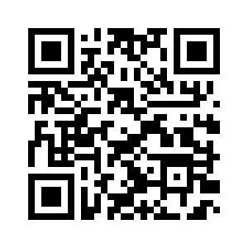
Scan the QR code above
to make a tax-deductible donation to ECI via our website, or visit:
endependence.org/donate

