
Annual Holiday Party: RSVP by November 19
This year's annual participant holiday party will be held on Thursday, December 3, 12:00pm – 3:00pm. The party is open to participants only. The cost is $5.00 per person and payable at the door by cash, check, or debit or credit card. Participants may register one guest for $5.00.
November 2026 Newsletter
REGISTRATION IS REQUIRED. Contact Katherine Keesler, kkeesler@endependence.org or 757-351-1569, to register by Thursday, November 19.
You are encouraged to be responsible for your own transportation to and from the party.

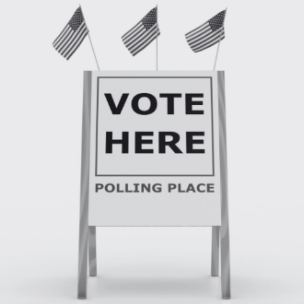
Election Day is November 3: Make a Plan to Vote
Election Day is Tuesday, November 3. This year, Virginians will cast ballots for the US Senate, House of Representatives, three amendments to the Virginia Constitution, and some City Council and School Board seats. Vist the Election Hub on the ECI website (https://endependence.org/election) for information on accessible voting, voter protection, and the constitutional amendments, as well as links to check your registration status, find out who is on your ballot, and more.

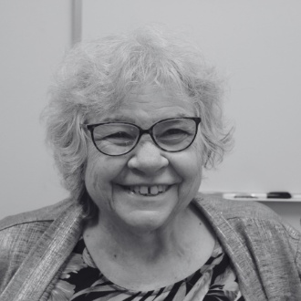
Save the Date: Retirement Celebration for Rena Lewis, Independent Living Coordinator
Rena Lewis, Independent Living Coordinator, retired in October after more than 30 years of service to the Endependence Center and the disability community. To celebrate Rena and her lasting impact, please join us on Tuesday, December 1, 2:00pm – 3:30pm, at ECI. More information will be shared as the date approaches.


Reminder: SNAP and Medicaid Work Requirements Changing
New federal rules changed SNAP (Supplemental Nutrition Assistance Program) work requirements and Medicaid work/community engagement requirements. Watch for letters from the Virginia Department of Social Services (DSS) or the Department of Medical Assistance Services (DMAS) – do not ignore these notices. For links for more information, visit https://endependence.org/alerts.

Endependence Center’s annual meeting was held on October 14 at the Jordan-Newby Anchor Branch Library in Norfolk. This year’s program, “Advocacy & 45 Years of Making an Impact”, showcased ECI’s long history of advocacy at the local, state, and federal levels, while honoring local community leaders and participants.

2026 ECI Award Recipients
Jerry O’Bryan Freedom Award – Charles Bryant
Outstanding City Award – City of Norfolk
Outstanding Service Award – Senator Angelia Williams Graves
William Patrick White Award for Advocacy – Delegate Phil Hernandez
Outstanding Agency Award – Hope House Foundation
Jane L. Majer Award for Independence – Erin Eveleigh
Lucy Salzberg Outstanding Student Award – Madison Boyd (not pictured)
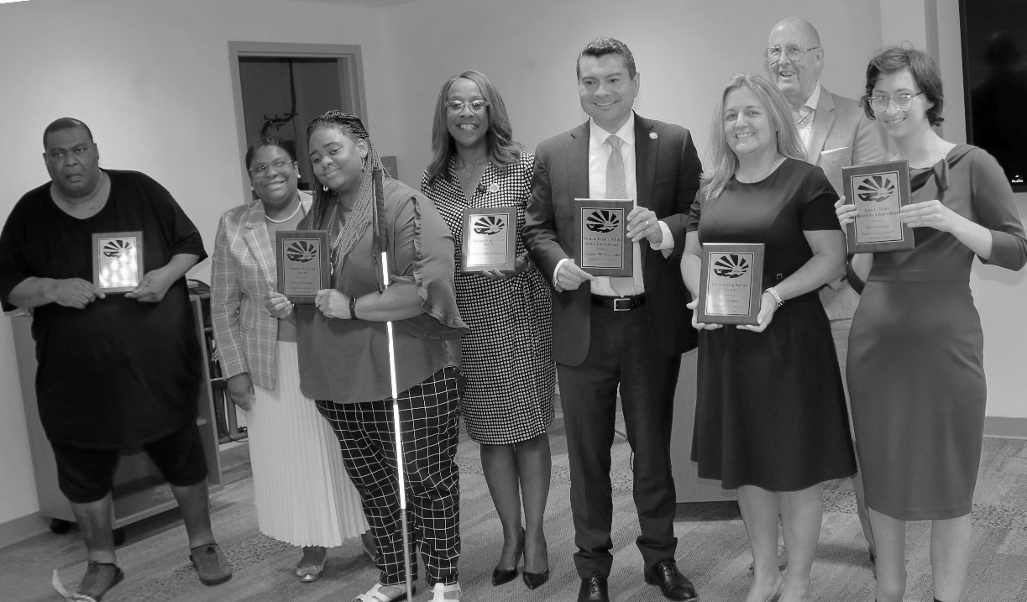


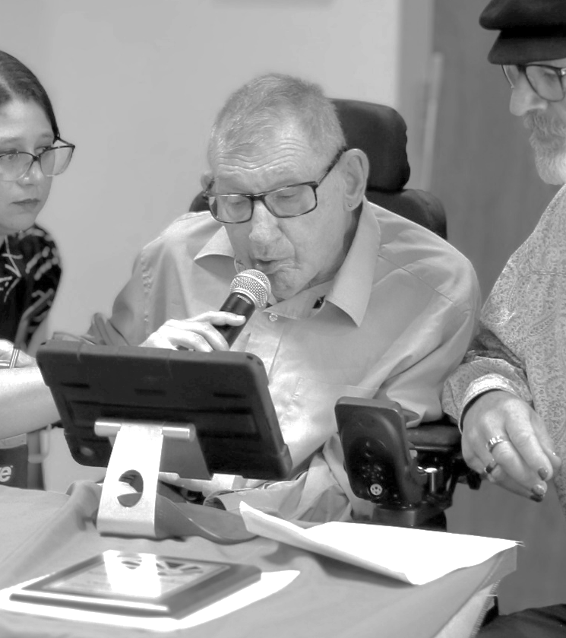
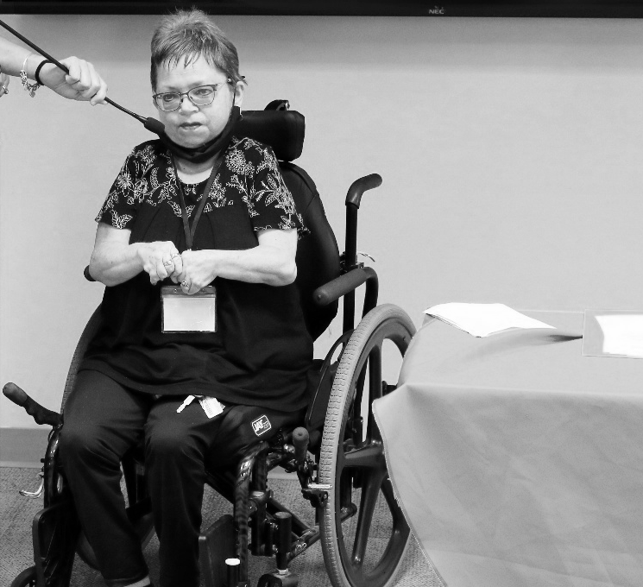
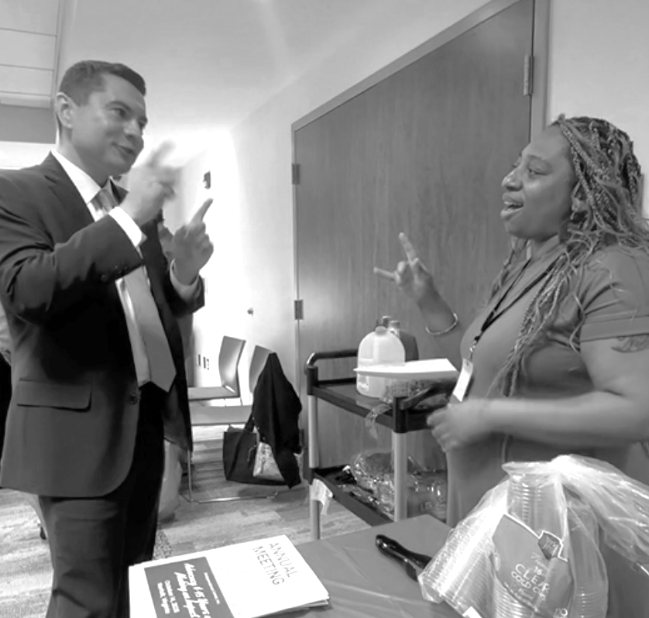
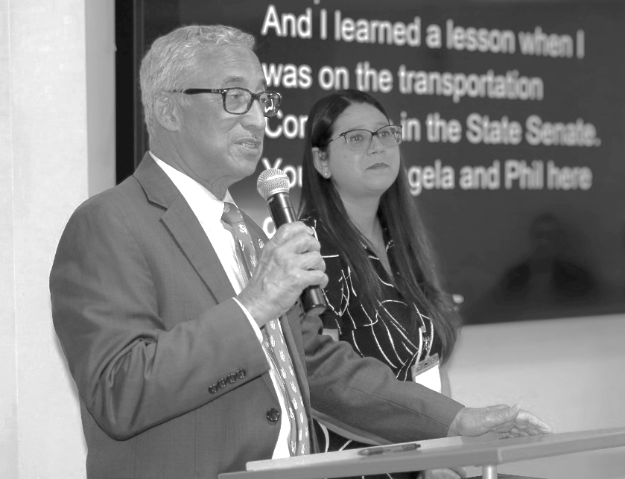
Pictured left: Congressman Bobby Scott, who represents the 3rd District of Virginia.
Pictured below: ECI Board President Lisbet Dula delivers closing remarks.
Pictured above: Delegate Phil Hernandez converses in ASL with ECI’s Deaf and Hard of Hearing Coordinator, Shernika Holley.
Pictured right: Guest Speaker Ed Turner shares “Why Advocacy Matters”

For more about this year’s annual meeting, please visit https://endependence.org/annual or scan the QR code on the left.

ECI Events
NOVEMBER 2026

Unless noted otherwise, events are held at ECI (6300 E. Virginia Beach Blvd., Norfolk)
4th Independent Living Skills Training: ABCs of Housing 2:00pm - 3:30pm
WED Join us for The ABCs of Housing, a presentation designed to help people with disabilities who have very low income learn about affordable housing options. We’ll cover how different housing programs work, how to apply, resources to help with your housing search, helpful application tips, and new tenant rights laws.

18th ECI Board of Directors Meeting 1:00pm - 3:00pm
WED ECI Board of Directors meetings are open to the public.

18th Connect & Grow 2:00pm - 3:30pm
WED Connect & Grow is a fun, welcoming space where ECI participants come together to make connections, share laughs, learn, and grow together as part of our independent living community.

19th City of Norfolk: Presentation of ADA Self-Evaluation 2:00pm - 3:30pm
THU The City of Norfolk has completed its ADA Self Evaluation and Transition Plan process. Please join us for a presentation from Adrianna Giddings, Management Analyst with the City of Norfolk, about the findings of the self-evaluation and what’s next for the City.

Community Events

Transportation tickets are NOT provided to attend community events.
There are no PEATC community office hours in November.
4th Transit Riders Advisory Committee (TRAC) 6:00pm
WED Hampton Roads Transit Norfolk Office (509 East 18th Street, Bldg. 4, Norfolk)
The Transit Riders Advisory Committee offers guidance to the Transportation District Commission of Hampton Roads (TDCHR) by providing feedback on service operations and customer experience. For more information, contact Henry Ryto at (757) 222‑6000 or hryto@hrtransit.org.

17th Participant-Led Event 12noon – 2:30pm
TUE Crazy Buffet & Grill (1745 Parkview Drive, Chesapeake)
This event is organized by participants.

21st TOUCH Group 11:00am – 1:00pm
SAT Endependence Center (6300 E. Virginia Beach Blvd., Norfolk)
Come and join us for some Bystander CPR Training with Emily Terifay, the Community Engagement Learning Program Coordinator at ODU, with medical students from Virginia Health Sciences. For questions, contact Montrell Rodgers at 757-238-1293 or VATOUCH.22@gmail.com.

SUNDAY | MONDAY | TUESDAY | WEDNESDAY | THURSDAY | FRIDAY | SATURDAY
1 | 2 | 3 | 4 | 5 | 6 | 7
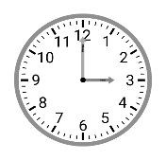  Daylight Saving  Time Ends |  |   Election Day | ILS Training: ABCs of Housing  @ ECI  2:00pm - 3:30pm  HRT Transit Riders Committee*  @ HRT (Norfolk)  6:00pm |  | Silent Dinner*  @ Lynnhaven Mall  5:30pm – 8:00pm
8 | 9 | 10 | 11 | 12 | 13 | 14
 |  |  |  |  |  | ASL Sip & Sign (Voices Off)*  @ Pinup Coffee at Farmhouse  10:00am – 11:00am  ASL Hangout*  @ Bull Island Brewing Co.  6:00pm – 9:00pm
Veteran's Day
(ECI Closed)
15 | 16 | 17 | 18 | 19 | 20 | 21
 |  | Participant-Led Event*  @ Crazy Buffet & Grill  12noon – 2:30pm | Board Meeting  @ ECI  1:00pm – 3:00pm  Connect & Grow  @ ECI  2:00pm - 3:30pm | Norfolk ADA Transition Plan Presentation  @ ECI  2:00pm - 3:30pm |  | TOUCH Group*  @ ECI  11:00am – 1:00pm
 |  |  |  | Deadline to Register for Participant Holiday Party |  | TOUCH Group*  @ ECI  11:00am – 1:00pm
22 | 23 | 24 | 25 | 26 | 27 | 28
 |  |  | 
 |  |  | ECI Closed in Observance of Thanksgiving
29 | 30
Events subject to change. Check the ECI website and Facebook for up-to-date information.
*This event is not organized by ECI; bus and Paratransit tickets will not be provided.


Disability Advocacy & Services

Endependence Center, Inc.
6300 East Virginia Beach Blvd
Norfolk, VA 23502

Phone:
(757) 461-8007 Voice
(757) 461-7527 TDD

E-Mail:
ecinorf@endependence.org

Website:
endependence.org

Accommodations

To request accommodations
for ECI activities:
(757) 351-1586 voice
(757) 461-7527 TDD
tmanno@endependence.org

To request an alternate
format of our newsletter:
(757) 351-1598 voice
(757) 461-7527 TDD
ehoapili@endependence.org

ELECTRONIC SERVICE REQUESTED

Facebook

@ECINorfolk
Endependence Center, Inc. Norfolk Virginia

Non-Profit Org.
U.S. Postage
PAID
Norfolk, VA
Permit No. 102

Support ECI
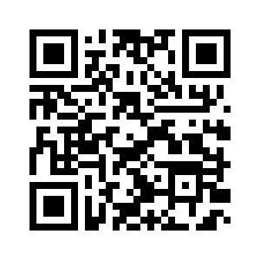
Scan the QR code above
to make a tax-deductible donation to ECI via our website, or visit:
endependence.org/donate

